Contents

Section 1: Scope 1
Section 2: Applicable Documents 1
Section 3: Definitions 2
Section 4: Procedures 2
Introduction 2
Selecting Subfolders 2
Downloading Copys of Controlled Documents 3
Refreshing the Main Sheet and Troubleshooting 3
Section 5: Revision History & Approval 4
Revision History 4
Approval 4

Section 1: Scope
This document teaches how to use the ABB Auburn Document Control Master File. After Reading this, users will know how to do the following:
- Download Controlled Documents
- Find Relavent Department Folders
- Refresh the Page

Section 2: Applicable Documents
The Document Control Master File can be found here:
\\XC-N-AWUSCVO1.elis.abb.com\ELIS_Americas\USmeaub\public\Everyone\Lean\Controlled Documents\Document Control Master File.xlsm

Section 3: Definitions
- Workbook – An excel document
- Sheet – A tab at the bottom left of the Workbook
- Cell – an individual box in the sheet which can contain a value. All cells have coordinates like “A1” or “X22”
- Directory – An address that the computer uses to store files on a computer or drive
- Document Control – A series of practices to ensure that documents are created, reviewed, distributed, and disposed of in a systematic, verifiable manner
- Document Control Master File (DCMF) – A workbook designed to track document revisions and approval in order to guarantee accurate files are used in all areas

Section 4: Procedures

Introduction
Users of the DCMF are able to access the most up-to-date and approved files in their plant’s document control directory. Users will only need to access the “Main” sheet and know how to use three features to make the most of the DCMF.

Selecting Subfolders
In the top left of the “Main” sheet is the “Sub Folder” selection box. Choosing different subfolder codes from this box displays all up-to-date and approved files from the “File Library” sheet. Although some subfolders have an intuitive name, others can be interpreted from the key at the top right of the “Main” sheet.
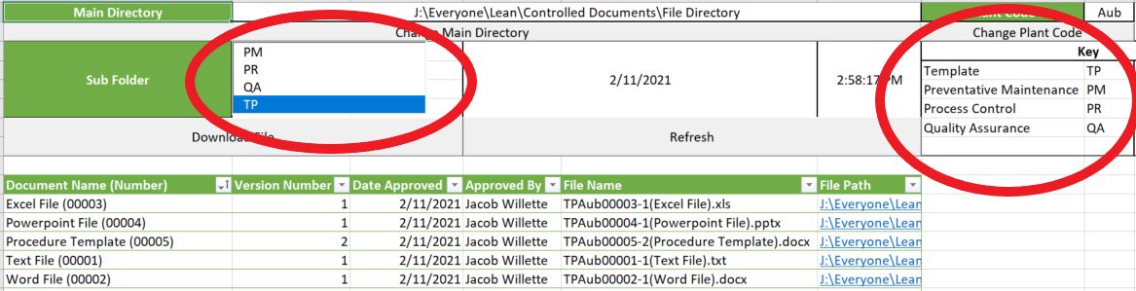

Downloading Copys of Controlled Documents
Clicking on the “Download File” button allows users to download files from the current document list. The user is prompted to select a file and choose a directory to send the file to (this will be the user’s “Documents” file by default). ONCE DOWNLOADED, THE FILE IS NO LONGER A CONTROLLED DOCUMENT AND IS OUT OF DATE.
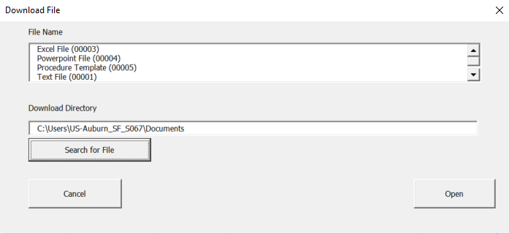

Refreshing the Main Sheet and Troubleshooting
If the last refresh date is red, that means the user MUST refresh the file in order to have controlled documents appear in their file list. If errors occur in the DCMF, troubleshoot in the following order: Refresh the document -> Close the document WITHOUT SAVING and reopen it -> Contact an administrator.
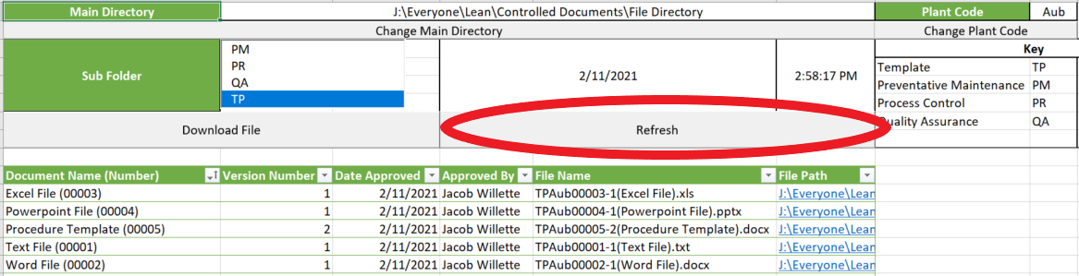

Section 5: Revision History & Approval

Revision History
Revision #: | Revision Date: | Revised By: | Revision Details:

Approval
The signatures below certify that this document has been reviewed and accepted.
Demonstrates that the signatories are aware of all the requirements contained herein and are committed to ensuring their provisions.

Description | Name | Signature | Position | Date
Prepared by | Jacob Willette |  | Quality and Continuous Improvement Intern | 2/11/2021
Reviewed and Approved by | Richard Bourgeois |  | Quality & Continuous Improvement Manager

