Contents
Section 1: Scope 1
Section 2: Applicable Documents 2
Section 3: Definitions 2
Section 4: Procedures 3
Introduction 3
File and Folder Structure 3
Importing a File 3
Creating a New File 4
Updating a File 4
Deleting Files 5
Approving Files 5
Changing Main Document Control Directory and Plant Code 6
Create and Delete Department Subfolders 7
Adding and Removing Authorized Users 9
Section 5: Revision History & Approval 9
Revision History 9
Approval 9

Section 1: Scope
This document teaches how to use the ABB Auburn Document Control Master File. After Reading this, Administrators will know how to do the following:
- Import Files
- Create New files
- Update Files
- Delete Files
- Approve Files
- Change the main document control directory and plant code
- Create and Delete subfolders for different departments
- Add and Remove Authorized users
- Standard file/folder naming conventions

Section 2: Applicable Documents
The Document Control Master File can be found here:
\\XC-N-AWUSCVO1.elis.abb.com\ELIS_Americas\USmeaub\public\Everyone\Lean\Controlled Documents\Document Control Master File.xlsm

Section 3: Definitions
- Workbook – An excel document
- Sheet – A tab at the bottom left of the Workbook
- Cell – an individual box in the sheet which can contain a value. All cells have coordinates like “A1” or “X22”
- Directory – An address that the computer uses to store files on a computer or drive
- Document Control Master File (DCMF) – A workbook designed to track document revisions and approval in order to guarantee accurate files are used in all areas
- Standard Format – The universal format for controlled document names. The format consists of the two character subfolder (department) code, the three character plant code, the five number document code, a hyphen, the document’s revision number, and the document’s title in parentheses. Examples of authentic file names:
  - PRAub00002-1(Document Control Master File Administrator).docx
  - QAmxc00102-13(Mexico City Quality Standards).pptx
  - PMLew24601-200(Preventative Maintenance Sheet).xlsx
- Standard Folder Structure – the format of folders in the main directory. In general, it takes the form, two character main directory \ subfolder \ year \ month. Examples:
  - C:\Main Dir\PR\2021\February
  - J:\Controlled Docs\QA\2000\March
  - W:\Directory\PM\1972\April
The Document Control Master File must be in the penultimate folder of the main directory in order to work correctly, so for the previous examples the Document Control Master File would be in:
  - C:\Main Dir\PR\2021\February
  - J:\Controlled Docs\QA\2000\March
  - W:\Directory\PM\1972\April

Section 4: Procedures

Introduction
In the DCMF Workbook there are two primary sheets the administrator uses. The first sheet is called “Main” because it is the sheet used for accessing controlled documents. Only approved files which are the most recent version will appear in “Main”. The second sheet is called “File Library” and contains a list of all controlled documents which have been imported into the system (approved or not). To view this sheet, the administrator must right click the “Main” sheet, click unhide, select “File Library”, click ok, and enter an admin password (this process only needs to happen once per session).
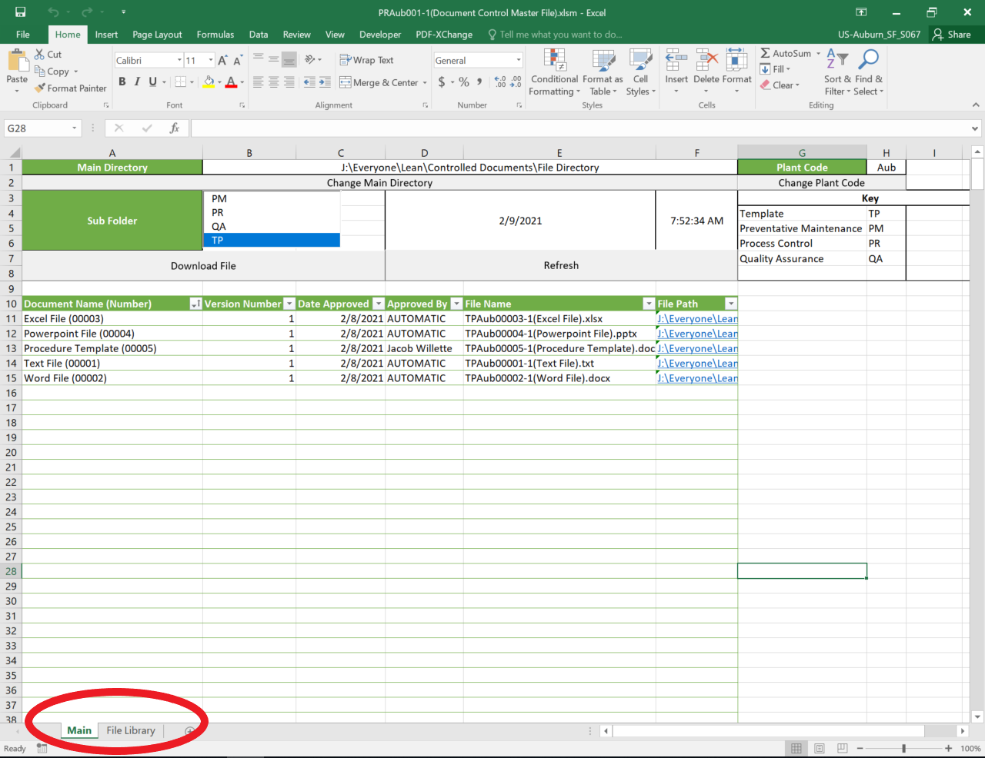

File and Folder Structure
Files and Folders in the main directory must follow the Standard Format and Standard Folder Structure outlined in section 3. The programs inside of the DCMF rely on these structures being intact in order to operate correctly. If an administrator needs to change something in the main directory, they MUST maintain these structures. Additionally, editing cells in any sheet in the DCMF can lead to a malfunction in it’s programs. The easiest way to fix issues caused by broken file and folder structure is by regularly making backups and being cautious with edits to the document.

Importing a File
Files are imported through the “File Library” sheet under the section “Document Controller Tools”. Once the “Import File” button is clicked, you are prompted to enter your password and are then given the option to search for the file you wish to import. The file you select MUST adhere to the standard format laid out in section 3.
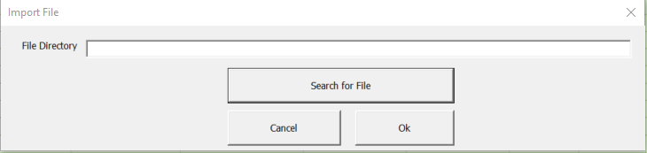

Creating a New File
Clicking on the “New File Button” in the “File Library” sheet gives an authorized user the ability to make a new controlled document. The administrator must select a sub folder, a document title (not adhering to the standard format), and a template for the new file to be based on. Templates are simply approved files in the subfolder “TP” so creating new templates has the same process as creating new files. The DCMF will automatically assign a document number and plant name to the file and make it version 1 by default.
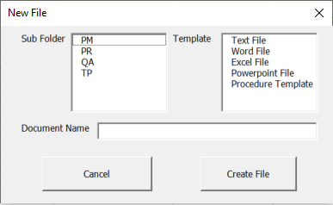

Updating a File
Clicking on the “Update File” button in the “File Library” sheet will make copies of existing documents and give them a higher version number. In the Update file window, filters can be applied to narrow down the list of files and find the file which needs to be updated. Only files with the highest version number for their document number appear in this list.
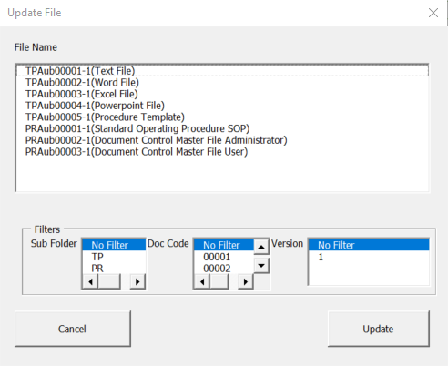

Deleting Files
Clicking on the “Delete File” button in the “File Library” sheet will PERMINENTLY delete files from the main directory and the “File Library”. In the Delete file window, filters can be applied to narrow down the list of files and find the file which needs to be deleted. THIS BUTTON SHOULD BE USED SPARINGLY TO PREVENT DATA LOSS AND REVISION HISTORY LOSS.
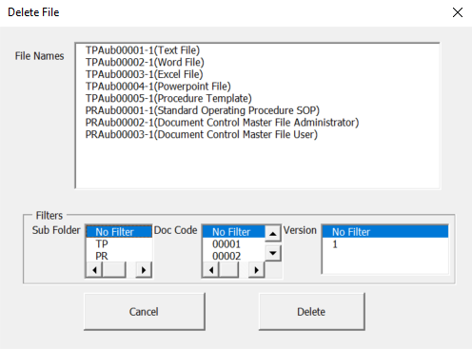

Approving Files
Clicking on the “Approve File” button in the “File Library” sheet allows authorized users to approve files for use. In the Approve file window, filters can be applied to narrow down the list of files and find the file which needs to be Approved. An authorized user must provide their credentials again to log the approval to the sheet. Files which are approved will appear in the “Main” sheet and have the ability to be accessed by non-administrators, so it is important that these files are ready for use BEFORE the “Approve File” button is utilized. Files that are unapproved are counted in the cell underneath “Document Controller Tools” in the “File Library” sheet. Some files may have authorization requirements independent from the DCMF, so it is important to open them and check if additional signatures are needed.
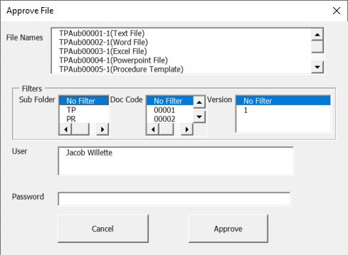

Changing Main Document Control Directory and Plant Code
On the “Main” sheet, administrators have the ability to change the location of the controlled documents directory and plant code. Changing the plant code has little to do with the functions of the DCMF besides naming new files, but changing the main directory improperly CAN CAUSE SERIOUS DAMAGE AND RESULT IN DATA LOSS. In the Change Main Directory window, the administrator is prompted to find a new directory to keep controlled documents. This new location should be in a drive that all computers have access to, should be used exclusively by the DCMF, and should not be tampered with after selected. Once the directory has been changed, the “File Library” sheet will be purged of files from the old directory and populate with existing files automatically (if the folder structure and file names adhere to the standard folder structure and standard format). These features should be used RARELY to prevent major mistakes and data loss.
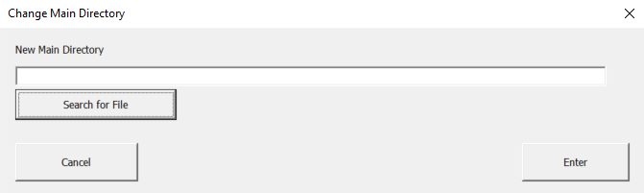

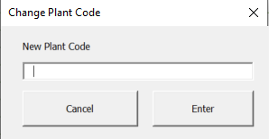

Create and Delete Department Subfolders
The “New Subfolder” and “Delete Subfolder” buttons are used to make subfolders which separate files by department or purpose. In the New Subfolder window, the administrator is prompted to provide a two-capital-letter subfolder name. It is good practice to give subfolders intuitive names, but since that is not always possible with only two characters, administrators should manually add their new subfolder and it’s meaning to the key located in the “Main” sheet. In the delete subfolder window, the admin is given a list of subfolders to choose from. Any of these subfolders can be deleted but this CANNOT BE UNDONE AND CAN LEAD TO MAJOR DATA LOSS. When you delete a subfolder, ALL of its files are also deleted, so this feature should be used sparingly and only in special circumstances.
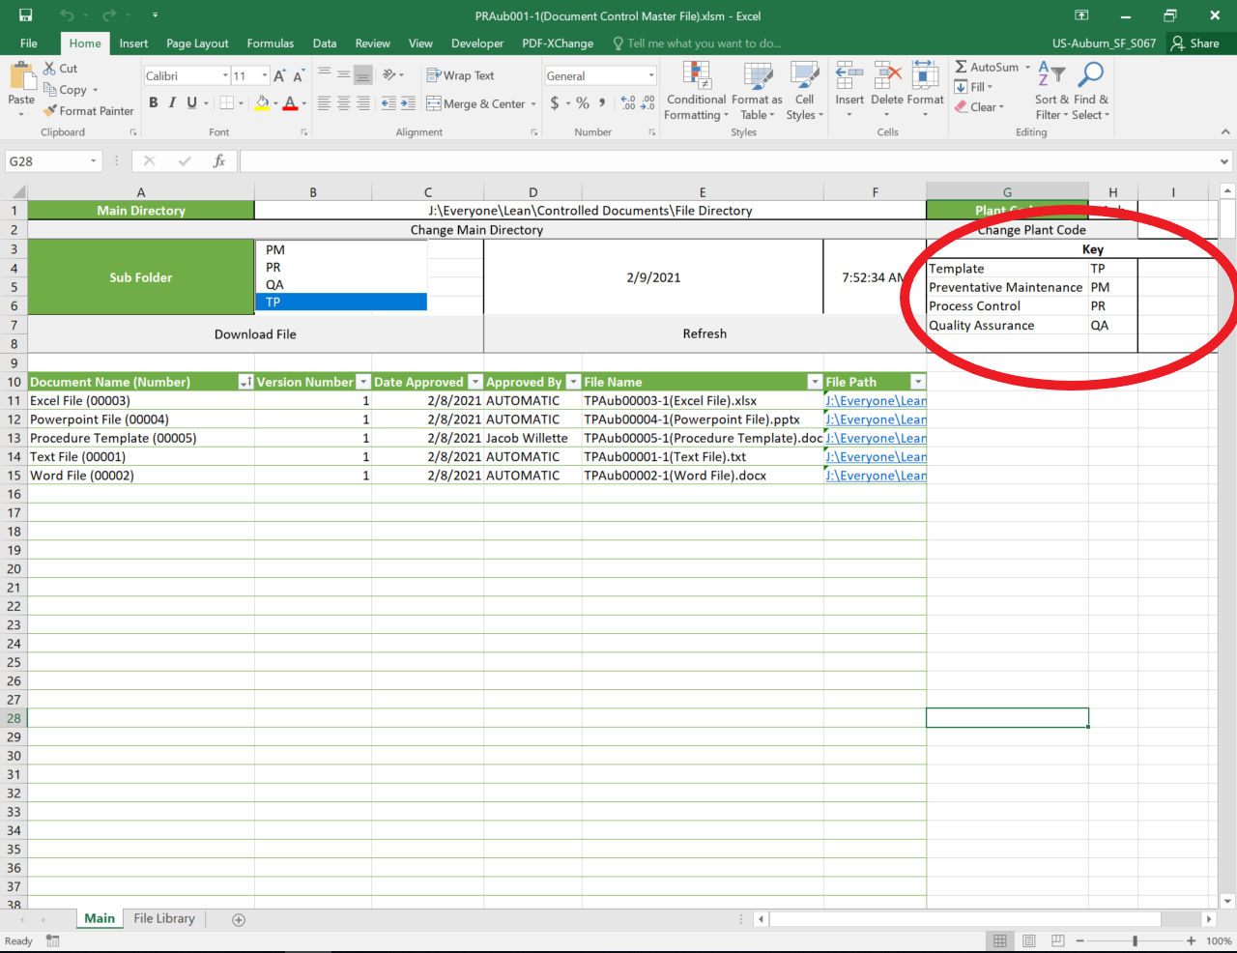
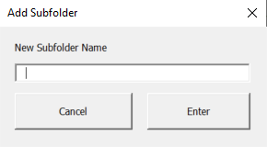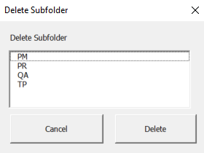

Adding and Removing Authorized Users
Authorized users have the ability to use every piece of functionality in the DCMF and should be chosen carefully. The “Add/Remove Authorized User” button gives the administrator the ability to edit permissions on the Document Control File. To add a user, enter their Name and password in the boxes to the right of the “Add” checkbox and click confirm. To remove a user, select a user from the left most list and click confirm. IF ALL AUTHORIZED USERS ARE REMOVED THE DOCUMENT CONTROL MASTER FILE WILL NOT WORK.
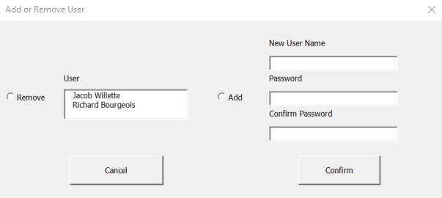

Section 5: Revision History & Approval

Revision History
Revision #: | Revision Date: | Revised By: | Revision Details:

Approval
The signatures below certify that this document has been reviewed and accepted.
Demonstrates that the signatories are aware of all the requirements contained herein and are committed to ensuring their provisions.

Description | Name | Signature | Position | Date
Prepared by | Jacob Willette |  | Quality and Continuous Improvement Intern | 2/9/2021
Reviewed and Approved by | Richard Bourgeois |  | Quality & Continuous Improvement Manager

