7.2:1 Single-Stage Gear Box
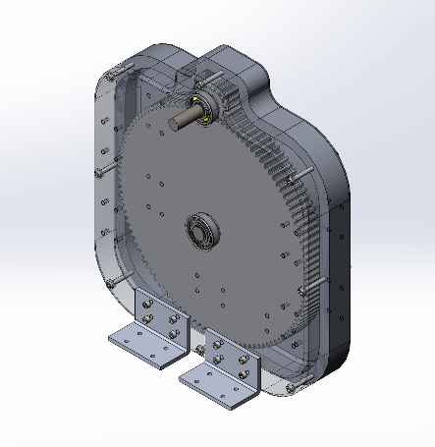

Prepared for:
Professor John Peter Voccio
Department of Mechanical Engineering and Technology
Wentworth Institute of Technology

By:
Andrew Lanzrath, Nial McInally, Jacob Willette
Group 3
Design of Machine Elements
December 13, 2020

Table of Contents
1 Abstract 3
2 Introduction 4
3 Design Specifications and “Off-the-Shelf” Parts 9
4 Component Design 11
4.1 Gears 11
4.1.1 Loading and Resultant Force Calculations 12
4.1.2 Lewis Bending Equation and Gear Material Selection 14
4.2 Key 16
4.2.1 Loading and Resultant Force Calculations 16
4.2.2 Key Length 16
4.3 Shafts 17
4.3.1 Material and Critical Points 17
4.3.2 Static Analysis 18
4.3.3 Fatigue Analysis 18
4.3.4 Finite Element Analysis 20
4.4 Bearings 25
4.4.1 Loading and Resultant Force Calculations 25
4.4.2 C10 Life Calculations 26
4.5 Case 27
4.5.1 Features 27
4.6 Interface 29
5 Drawings 30
6 Conclusions 35
7 References 36

Abstract

The goal of this project was to design a 7.2:1 gear box. A comprehensive analysis of the multiple components used in the gear box was conducted to determine the appropriate part for selection from a variety of component manufacturers. The report below provides an introduction on the fundamentals of gear boxes and the components that make up a gear box along with briefly discussing the load analyses conducted for each component. Then, the process of part selection and load analyses is provided in detail. As part of the analysis, a finite element analysis (FEA) study was performed for certain components in the gear box. Following the section on analysis are the table of interfaces and drawings of the gear box assembly. The gear box designed fulfills the design goals and initially provided design requirements.

Introduction

A gear box is simply an enclosed geartrain. More specifically, it is a mechanical component comprised of a series of mating gears, shafts, and bearing as well as other often included components such as keys and shaft collars. The terms gear box, gear head, and gear reducer are often used interchangeably to refer to the same object. Gear boxes are used for rotary motion power transmission by taking advantage of the inverse proportionality of speed and torque. For example, many gear boxes are used to reduce the speed of the input gear in order to increase the torque. There are many different types of gear boxes and many different applications for each type.
There are 5 general categories of gear boxes: spur, planetary, helical, worm, and bevel gear boxes [1], and each gear box is classified by the type of gears it uses. Spur gear boxes are useful in situations when power needs to be transmitted between two parallel shafts. Primarily used in contemporary technologies such as robotics, planetary gear box designs can achieve high torque in a small space and are known for their high endurance. Worm gear boxes are used to transmit power when the shafts are perpendicular to each other. Helical gear boxes are very versatile. They can transmit power for shafts that are in parallel or perpendicular arrangements because the teeth on helical gears are cut at an angle. Also, these gear boxes operate smoother than others and can accommodate high load angles. The teeth on the bevel gears used in bevel gear boxes are organized on a conical surface, which, like the worm gear, make it an appropriate candidate for transmitting power from perpendicular shafts.
There are many different applications for gear boxes spanning a wide variety of industries. Generally, gear boxes are used anywhere that machines utilize power transmission, and some specific industries in which gear boxes are used include aerospace, mining, construction, robotics, textile machinery, food and drink machinery, and the automotive industry. [2] The five aforementioned types of gear boxes are used in different industries because the mechanical needs change based on the processes involved. Spur gears are often used in packaging and power plants. The unique design of planetary gears lends them to be used in lifts, cranes, and other machine tools. Because worm gears can tolerate high shock loads, they are used in mining, presses, and elevators or escalators. Helical gears are also used in elevators as well as in the oil industry and for cutting machines. Finally, bevel gear boxes are often used in power plants, steel plants, and for automotive applications.
Gear boxes can be quite complex systems to design, in part, because of a myriad of combinations related to the components chosen. One of the main series of choices relates to the gears in the gear box. The design requirements specified that spur gears be used so those will be the only type of gears discussed further. In the simplest gear box designs, there are two gears. The gear that receives the input, the pinion, is the smaller gear. The gear mated to the pinion is simply referred to as the gear. In order for the two gears to function properly in unison, both must have the same diametral pitch, the number of teeth per inch, and pressure angle, the angle between the pressure line and the perpendicular to the line of the gear centers. [3] See figure 2.1 for a diagram detailing pressure angle. There are a range of diametral pitches that can be selected when choosing gears for the assembly, and some common pressure angles are 14.5°, 20°, and 25°.
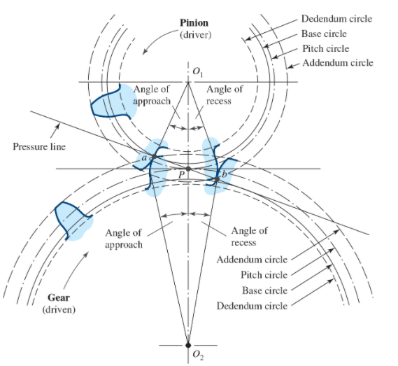
Figure 2.1 – Tooth Action
In addition to pressure angle and diametral pitch, another factor that plays a role in gear selection is the gear ratio. To determine the appropriate gear ratio for the gear box, considerations about the desired amount of power transition as well as the size of the gear box are important. The gear ratio is the fraction of the number of teeth of the driven gear and the pinion, or driving gear. Gear boxes with large gear ratios take high input speeds and transmit that power as a large torque output at a reduced speed. Limitations to the size of the gear box can limit the gear ratio used. Equation 1 shows various manifestations of the gear ratio using the ratio of the number of teeth, ratio of diameters, and ratio of angular velocities.
$Gear Ratio= \frac{N_{driven}}{N_{driving}}=\frac{d_{driven}}{d_{driving}}=\left|\frac{ω_{driving}}{ω_{driven}}\right|$ (1)
$N=number of teeth, d=diameter, ω=angular velocity$
The material of the gears chosen is also very important. Some of the points to consider when choosing a material for gears or for any other part to be used in the gear box are the cost, manufacturability, environmental impact, mechanical attributes, and physical properties. [4] The budget for the project directs the cost component for material selection, and the manufacturability also factors into the cost because certain materials are difficult to work with or require specialized equipment so that greatly reduces the number of potential manufacturers to produce the design. Engineers also need to be aware of the environmental impacts associated with certain materials. Such considerations include the processes needed to take the raw material and transform it into a workable state and the material’s recyclability. The two most important material selection criteria for the performance of the gear box are the material’s mechanical attributes and physical properties. The main properties of interest are the ultimate and yield strengths, but a material’s response to changes in temperature and the fatigue endurance of the material are also important. Another factor to consider with material performance is what manufacturing process is selected since different processes affect the physical properties of the material. For example, cold-working processes such as cold rolling and cold drawing result “in a large increase in yield strength, an increase in ultimate strength and hardness, and a decrease in ductility.” [3] These material properties can be referenced from a variety of sources. The properties for some types of steel treated with either hot-rolled or cold-drawn processes are listed in Table A-20 at [3].
One final consideration when doing a mechanical analysis of the gears for a gear box is the bending stress experienced by the gear teeth. This can be estimated using the Lewis bending equation. Equation 2 is the Lewis bending equation that accounts for dynamic effects with the inclusion of the velocity factor. Omitting the velocity factor would result in the basic form of the Lewis bending equation. Equation 3 is the equivalent of Equation 2 for metric units.
$σ=\frac{K_{v}W^{t}P}{FY}$ (2)
$σ=\frac{K_{v}W^{t}}{FmY}$ (3)
$σ=bending stress, K_{v}=velocity factor, { W}^{t}=trasmitted load,$
$P=diametral pitch, F=face width, Y=Lewis form factor, m=module$
Table 14-2 at [3] contains some values for the Lewis form factor, and equations 14-4(a-b), 14-5(a-b), and 14-6(a-d) at [3] detail various equations to calculate the velocity factor for different design situations.
The gears are situated on the shafts, which means there must be a careful mechanical analysis done to ensure the shafts are capable of performing the required functions. Shafts must be able to withstand torsional forces from rotation deflection from loads that cause bending. In addition, the shaft’s endurance strength is an important calculation since the forces acting on the shaft are often repetitive. The most important areas for analysis are known as the critical locations. The critical locations will typically be on the outer surface in places where the bending moment is large, torque is present, and discontinuities cause stress concentrations. One potential critical location is the location of the key where the gear is connected to the shaft. [3] The bending and torsional forces have alternating and mean components. The equations below show the general equations for the alternating and mean components of the bending and torsional stresses and the equations modified for assumptions of a solid shaft with a round cross section.
$σ_{a}=K_{f}\frac{M_{a}c}{I}=K_{f}\frac{32M_{a}}{πd^{3}}$ (4)
$σ_{m}=K_{f}\frac{M_{m}c}{I}=K_{f}\frac{32M_{m}}{πd^{3}}$ (5)
$τ_{a}=K_{fs}\frac{T_{a}r}{J}=K_{fs}\frac{16T_{a}}{πd^{3}}$ (6)
$τ_{m}=K_{fs}\frac{T_{m}r}{J}=K_{fs}\frac{16T_{m}}{πd^{3}}$ (7)
$σ_{a}=alternating bending stress, σ_{m}=mean bending stress,$
$τ_{a}= alternating torsional shear stress, τ_{m}=mean torsional shear stress,$
$M_{a}=alternating bending moment, M_{m}=mean bending moment,$
$T_{a}=alternating torque, T_{m}=mean torque$
$K_{f}=fatigue stress concentration factor for bending,$
$K_{fs}=fatigue stress concentration factor for torsion,$
$c=centroidal distance of the cross section,$
$r=distance from center to stressed surface,$
$I=centroidal moment of inertia,$
$J=polar moment of inertia$
Now that an analysis of the factors that contribute to the static failure of the shaft have been accounted for, it is also important to do an analysis to determine how the shaft may fail from fatigue. Fatigue failure is the failure of a machine element due to repeated cycling of the part. One important number that plays a role in many fatigue calculations is the endurance limit, which is the highest stress a material can withstand for an infinite number of cycles without failure. The Marin equation incorporates factors that quantify “the effects of surface condition, size, loading, temperature,” and some other miscellaneous factors. [3]
$S_{e}=k_{a}k_{b}k_{c}k_{d}k_{e}S_{e}^{'}$ (8)
$S_{e}=endurance limit, S_{e}^{'}=rotary-beam test specimen endurance limit,$
$k_{a}=surface factor, k_{b}=size factor, k_{c}=load factor, k_{d}=temperature factor,$
$k_{e}=reliability factor$
Equations for the different factors can be found at [3] (see 309-318).
The bearings are another important component in the gear box. They are a means of supporting the torque and speeds of the rotating shafts and gears. Bearings also make the rotation smoother. When using bearings, the bearing life needs to be taken into consideration. There are two common life measures: the number of revolutions of the inner ring with a stationary outer ring until the first tangible evidence of fatigue is observed, or the number of hours of use at standard angular speed until the first tangible evidence of fatigue is observed. [3] The equation for the catalog load rating is shown in Equation 9. The catalog load rating is “the radial load that causes 10 percent of a group of bearings to fail at the bearing manufacturer’s rating life.” [3] Other names for the catalog load rating are the basic dynamic load rating or more simply, load rating.
$C_{10}=F_{R}=F_{D}{(\frac{L_{D}}{L_{R}})}^{1/a}=F_{D}{(\frac{ϑ_{D}n_{D}60}{ϑ_{R}n_{R}60})}^{1/a}$ (9)
$C_{10}=catalog load rating, F_{R}=catalog rating, F_{D}=desired radial load,$
$L_{R}=rating life \left(revolutions\right), L_{D}=desired life \left(revolutions\right),$
$ϑ_{R}=rating life \left(hours\right), ϑ_{D}=desired life \left(hours\right),$
$a=3 for ball bearings,\frac{10}{3}for roller bearings$

Design Specifications and “Off-the-Shelf” Parts

General:
General Specifications |  | Input Specifications |  | Output Specifications
Design Life | 4000 Hours | Input Power | 3 HP | Output Power | 3 HP
Static Factor of Safety | 2.25 | Loading Factor | 1.5 | Loading Factor | 1.5
Fatigue Factor of Safety | 1.25 | Input Speed | 1800 RPM | Output Speed | 250 RPM
Reliability Index | 0.9
Target Gear Ratio | 7.2 ± 1%

Gears:
Gear Specifications
Supplier | Rush Gears
Pressure Angle | 20°
Diametral Pitch | 8 teeth/in
True Gear Ratio | 7.1875
Pinion
Number of Teeth | 16 teeth
Pitch Diameter | 2 in
Face Width | 1.5 in
Gear
Number of Teeth | 115 teeth
Pitch Diameter | 14.375 in
Face Width | 1.75 in

Bearings:
Bearing Specifications
Pinion
Static Load | 1472 lbs
Fatigue Load | 2855 lbs
Bore | 0.75 in
Outside Diameter | 1.875 in
Width | 0.5627 in
Gear
Static Load | 1720 lbs
Dynamic Load | 3147 lbs
Bore | 0.875 in
Outside Diameter | 2.00 in
Width | 0.5625 in

Shafts:
Shaft Specifications
Input Length | 2.0 in
Output Length | 2.5 in

Retaining Rings:
Retaining Ring Specifications
Pinion
Supplier | McMaster-Carr
Part Number | 91590A128
Gear
Supplier | McMaster-Carr
Part Number | 91590A131

Fasteners:
Fastener Specifications
¼-20 x 3.75 Socket Cap Hex Screw | Qty: 8
¼-20 x 5.625 Socket Cap Hex Screw | Qty: 16
¼-20 Hex Nut | Qty: 8

Component Design

Gears

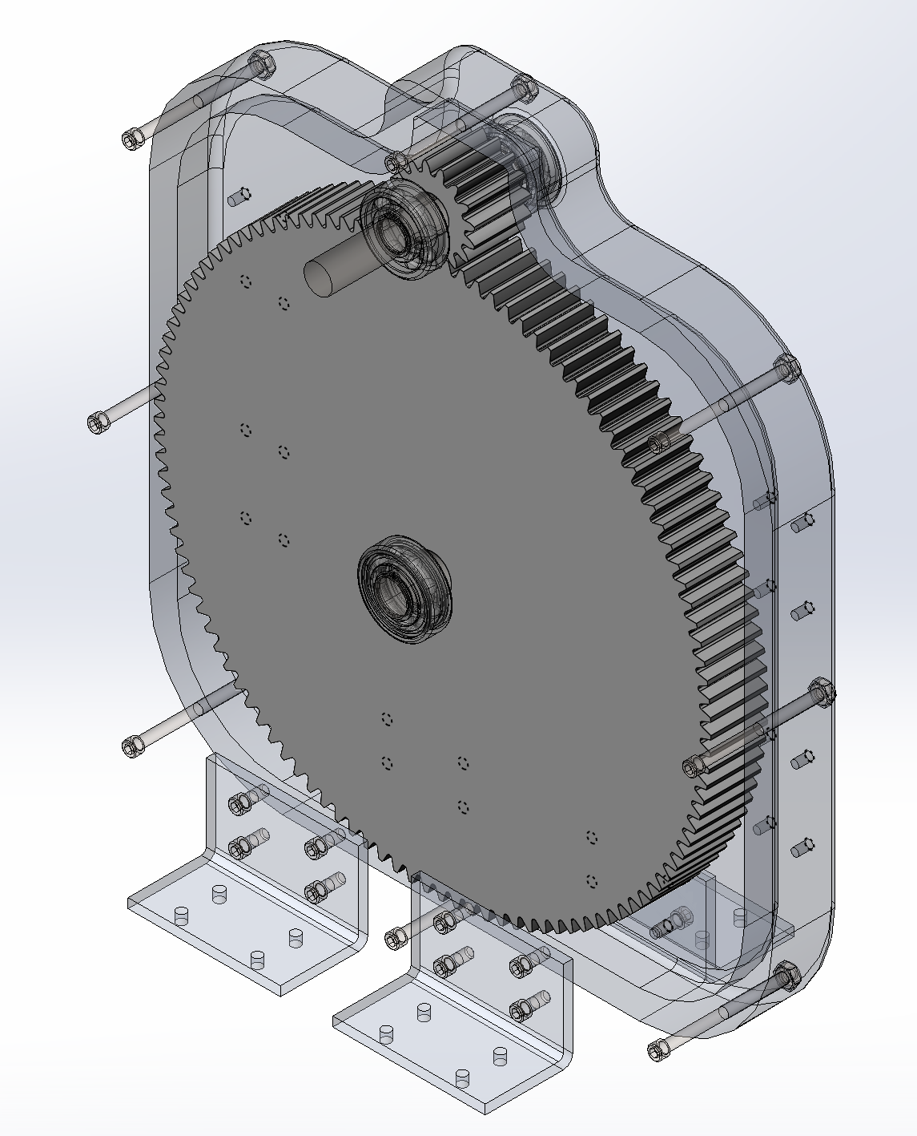
Figure 4.1 – Gears

Loading and Resultant Force Calculations

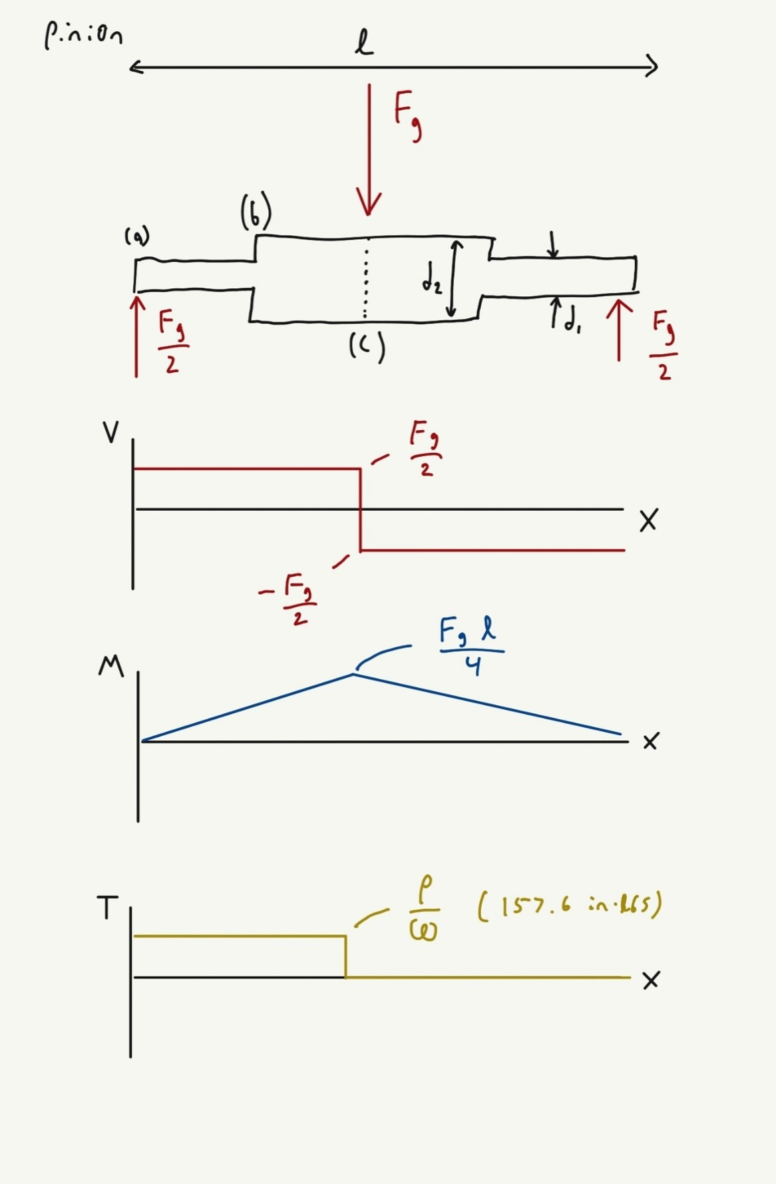
Figure 4.2 – Pinion Shaft Free Body Diagram

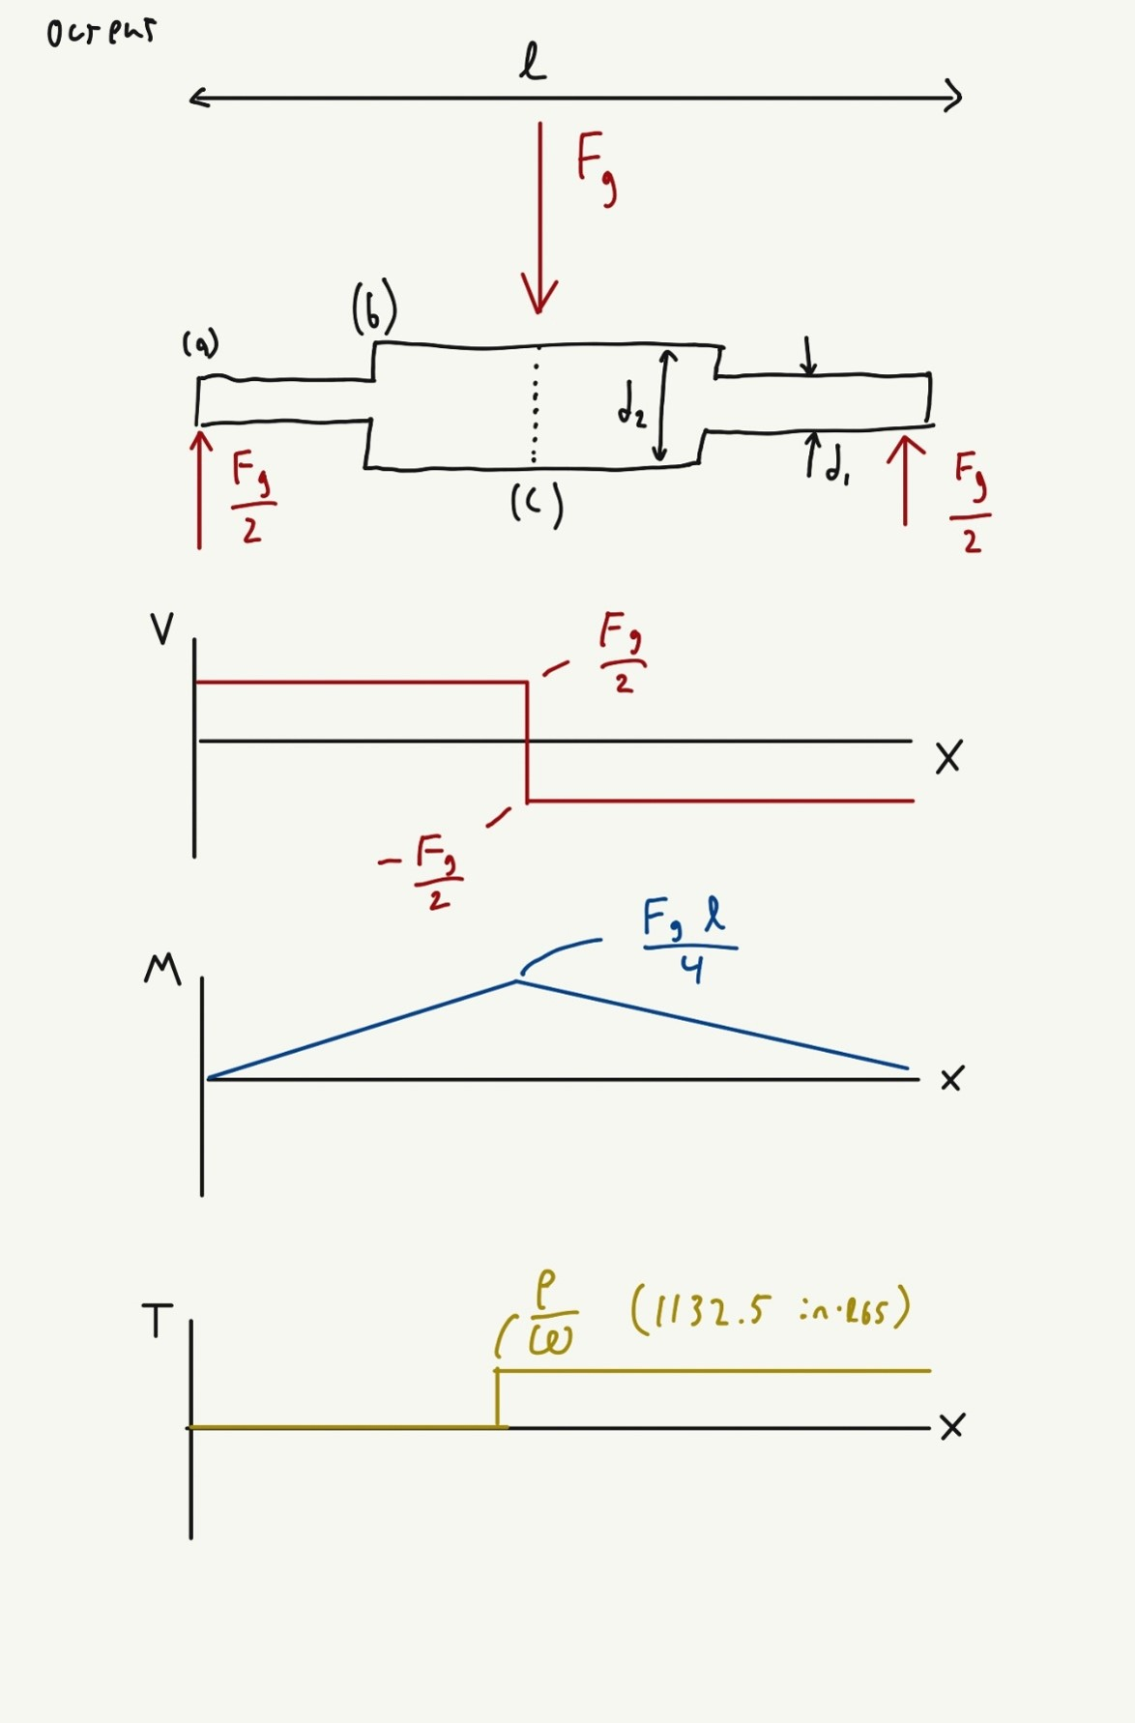
Figure 4.3 – Output Shaft Free Body Diagram

After an initial set of gears with an appropriate gear ratio and specifications were selected, the free-body diagrams (FBD) shown in figures 4.2-3 were utilized to calculate the transmitted and radial forces on both shafts by the gear’s interactions. From the FBD the following equations can be derived:

$\frac{2*T}{D*sin⁡(α)}=F_{r}$ (10)

$\frac{2*T}{D*sin⁡(α)}=F_{t}$ (11)

$\sqrt{{F_{t}}^{2}+{F_{t}}^{2}}=F_{g}$ (12)

Where, T is torque transmitted on the gear, D is the pitch diameter of the gear, alpha is the pitch angle, F_{r} is the radial component, F_{t} is the tangential component, and F_{g} is the resultant force. From the specifications in section 3, these equations yield a resultant force of 490.25 lbf on the shaft. This number is important in various other calculations later on in the design of the gear box for static and fatigue calculations alike.

Lewis Bending Equation and Gear Material Selection

The Lewis Bending Equation (equation 3) calculates the stresses within the teeth of meshing gears. It relies on the following and a factor provided by the gear supplier:

$\frac{π*D*ω}{12}=V_{p}$ (13)
$\frac{V_{p}+1200}{1200}=f_{V}$ (14)

Where, D is pitch diameter, omega is angular speed in RPM, V_{p} is pitch line velocity, and fv is the velocity factor. It was found that the bending stress in the selected gears was very low and a plethora of materials would be suitable. Aluminum 6061-T6 was selected because of its low cost and light weight.

Key

Loading and Resultant Force Calculations

The compression of the keys in this gearbox are insignificant compared to the shear caused by the rotation of the gears. Because of this, only the tangential component of the gear force is accounted for in the loading of the key.

Key Length

The minimum key length necessary for a square key is given by this equation:

$L= \frac{2*F_{t}}{w*S_{ykey}}$ (15)

Where, F_{t} is tangential force, w is the width of the key, and S_{y, key} is the yield strength of the key material. Fortunately, the minimum length calculated (0.09 in) was far less than the width of the gears chosen (1.5 in).

Shafts

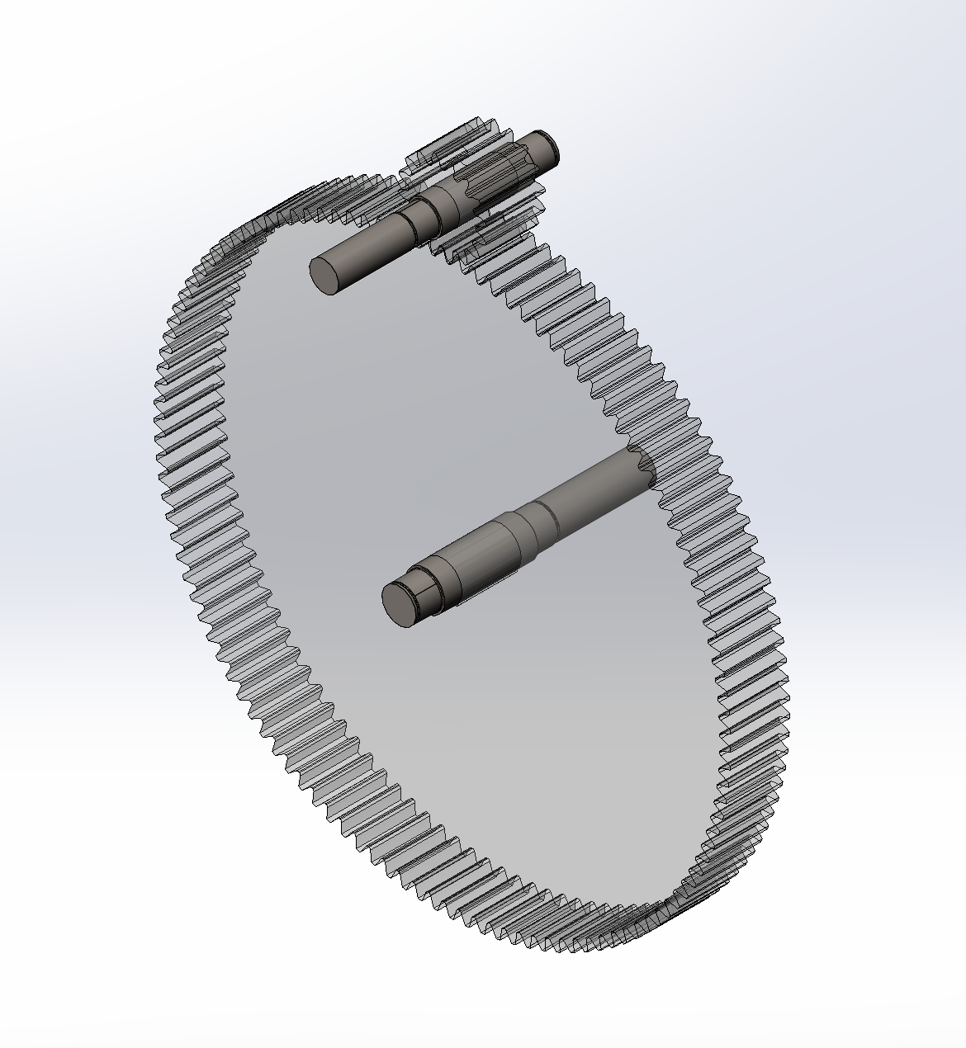
Figure 4.4 – Shafts

Material and Critical Points

The material chosen for the design group was AISI 1020 Steel, which has a yield strength of 51 ksi and an ultimate strength of 61 ksi. On the shaft, three critical points were identified for calculating minimum diameter and can be seen on the FBD in section 4.1.1. The following points were analyzed on both shafts:
Point A represents the left and right extremities of the shaft and are located at the center of the ball bearing supports. There are no stress concentrations at this point, so the stress concentration factors are 1
Point B represents the predicted step in the shaft from the inner diameter of the bearing to the bore diameter of the gear. The stress concentration factors listed for this shaft discontinuity are 1.7 for tensile stress and 1.5 for shear [3].
Point C is the location of highest bending moment. It also has a stress concentration at the keyway which yields stress concentration factors of 2.14 for tensile and 3 for shear stress [3]. This location is essential for the design of the shafts because it is where all the internal stresses of the gearbox culminate.

Static Analysis

Static analysis was done on the shaft at the three critical points to determine it’s minimum diameters. The following equation takes into account stress factors, material properties, and calculated loading:

$d= \sqrt[3]{\frac{16n}{πS_{y}}*\sqrt[2]{4{(M_{a}k_{t})}^{2}+3{(T_{m}k_{ts})}^{2}}}$ (16)

Where, d is minimum diameter, n is static factor of safety, S_{y} is yield strength of the shaft material, M_{a} is the alternating moment (same as max moment in the FBD), k_{t} is the stress concentration factor, T_{m} is the mean torque (same as the torque in the FBD), and k_{ts} is the shear stress concentration factor. As an example, the minimum static diameter of point c on the input shaft is 0.73 in. These minimums do not account for the lifetime of the gearbox and shafts of this minimum size have the chance to fail because of fatigue.

Fatigue Analysis

To begin calculating the minimum fatigue diameter the endurance strength is necessary. The unmodified endurance strengths are half of the ultimate strength of the material (mentioned in section 4.3.1). Several factors were then calculated to find the true endurance strengths at the critical points.
The surface factor was calculated with the following equation and the curve fit factors for machined material [3]:

$k_{a}=2.7{S_{ut}}^{-0.265}$ (17)

Where, k_{a} is the surface factor and S_{ut} is the ultimate strength of the material. The size factor was initially based on the static minimum diameter and used this equation [3]:

$k_{b}=0.879d^{-0.107}$ (18)

Where, k_{b} is the size factor and d is the diameter at that point. The loading factor and temperature factor were both 1 because the shaft was undergoing bending at room temperature. The reliability factor was listed as 0.897 for the reliability of 0.9 desired [3]. The final endurance strength was calculated with equation 8.

Next, notch sensitivity at each location was needed to calculate fatigue stress concentration factors. The following equations were used [3]:

$a=0.246-3.08*{10}^{-3}*{S_{ut}}^{1}+1.51*{10}^{-5}*{S_{ut}}^{2}-2.67*{10}^{-8}*{S_{ut}}^{3}$ (19)

$a_{s}=0.19-2.51*{10}^{-3}*{S_{ut}}^{1}+1.35*{10}^{-5}*{S_{ut}}^{2}-2.67*{10}^{-8}*{S_{ut}}^{3}$ (20)

$q= \frac{1}{1+\frac{\sqrt{a}}{\sqrt{r}}}$ (21)

$q_{s}= \frac{1}{1+\frac{\sqrt{a_{s}}}{\sqrt{r}}}$ (22)

Where, S_{ut} is ultimate strength, a and a_{s} are the notch sensitivity factors for tensile and shear loading, q and q_{s} are the notch sensitivities for tensile and shear loading, and r is the radius of the discontinuity (infinite in flat regions). From there, fatigue stress concentration factors were calculated from notch sensitivity and static stress concentration factors:

$k_{f}=1+q(k_{t}-1)$ (23)

$k_{fs}=1+q_{ts}(k_{ts}-1)$ (24)

Where k_{f} and k_{fs} are the fatigue stress concentration factors for tensile and shear loading, q and q_{fs} are the notch sensitivities for tensile and shear loading, and k_{t} and kt_{s} are the stress concentration factors for tensile and shear loading, Finally, the minimum fatigue diameter could be calculated from this equation:

$d= \sqrt[3]{\frac{16n}{π}*\sqrt[2]{4{(\frac{M_{a}k_{f}}{S_{e}})}^{2}+3{(\frac{T_{m}k_{fs}}{S_{y}})}^{2}}}$ (25)

Where, d is the minimum fatigue diameter, n is the fatigue factor of safety, k and k_{f} are the fatigue stress concentration factors for tensile and shear loading, M_{a} is the alternating moment (same as max moment in the FBD), T_{m} is the mean torque (same as the torque in the FBD), S_{e} is ultimate strength, and S_{y} is yield strength. Goal seek was needed to solve this equation because the endurance stress is dependent on the diameter. In the end, the minimum diameter was found for all locations on both shafts to operate for millions of cycles. As an example, point a on the input shaft had a minimum fatigue diameter of 0.69 in.

Finite Element Analysis

A Solidworks CAD model was created to test the shafts with finite element analysis. Von Mises stresses, shaft displacement, and resonant frequency plots were created to prove the hand calculations were accurate and the shafts were suitable for operation.

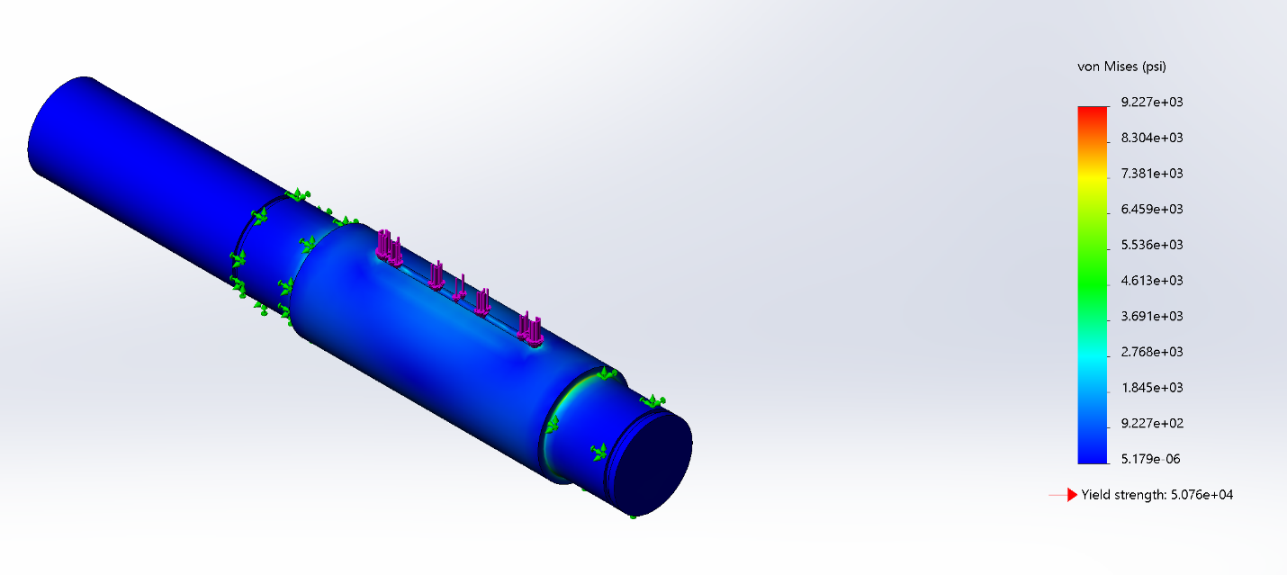
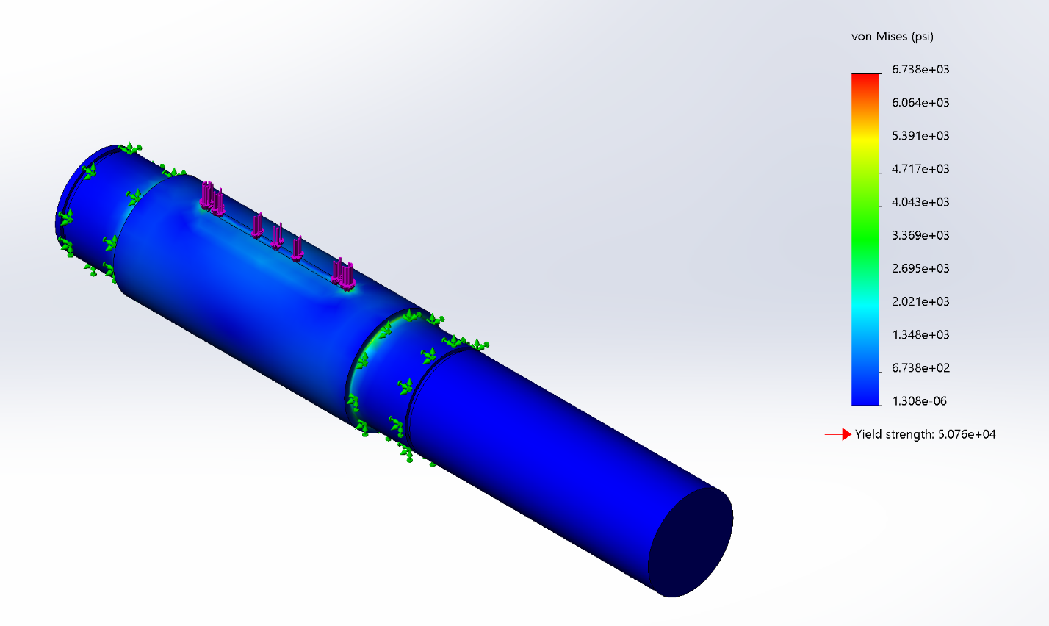
Figure 4.5 – Von Mises Stress Plots (Input and Output Respectively)

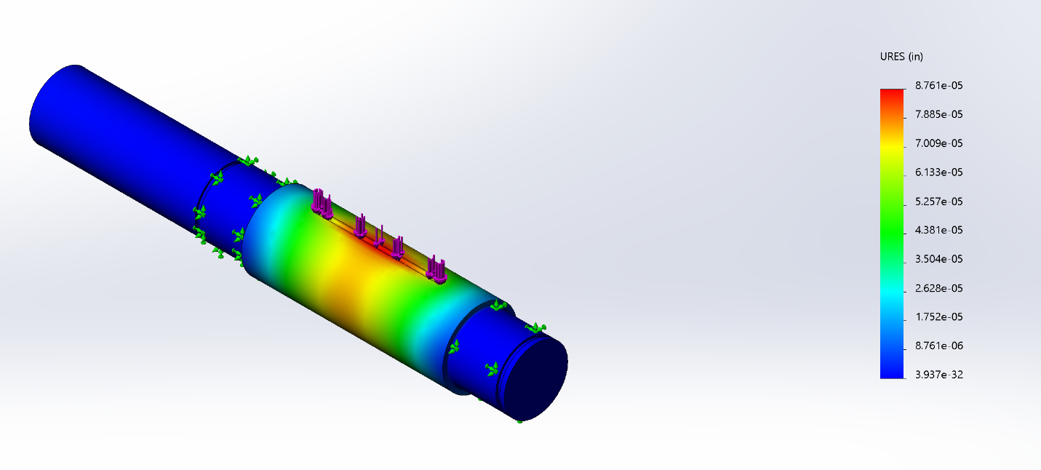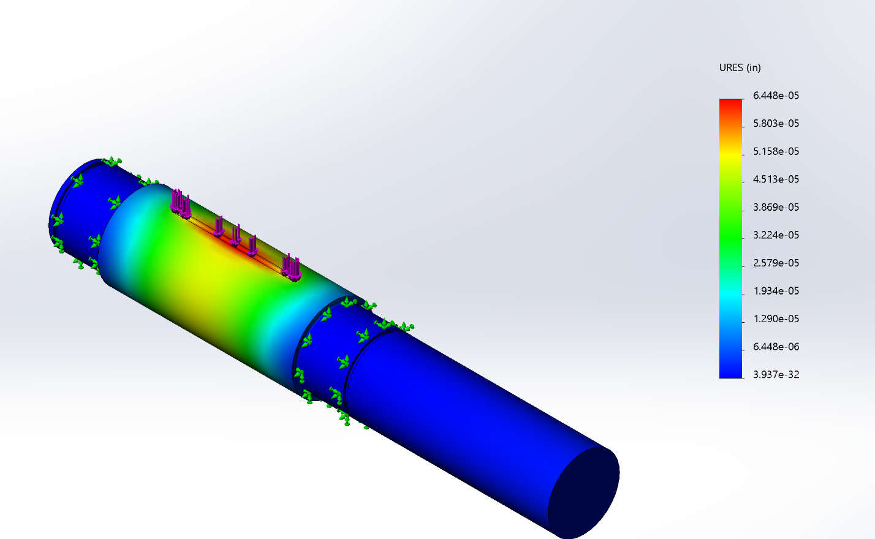
Figure 4.6 – Displacement Plots (Input and Output Respectively)

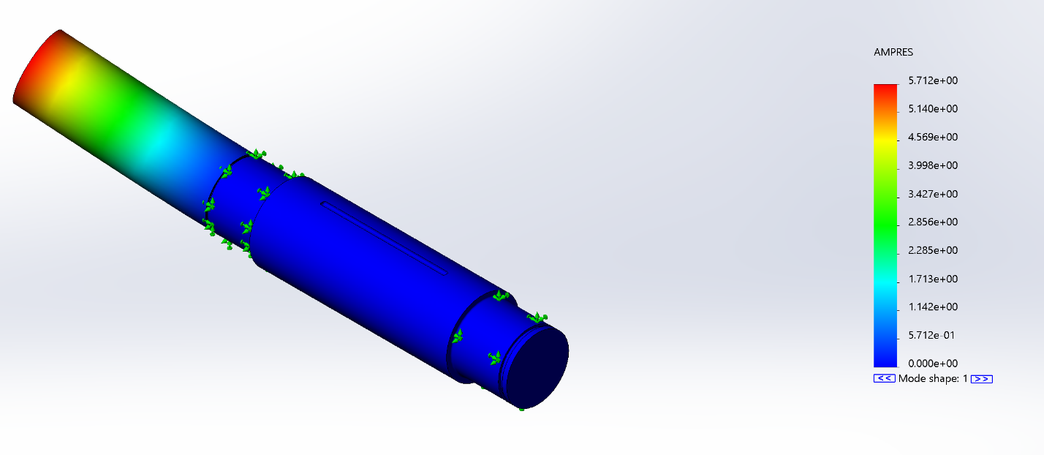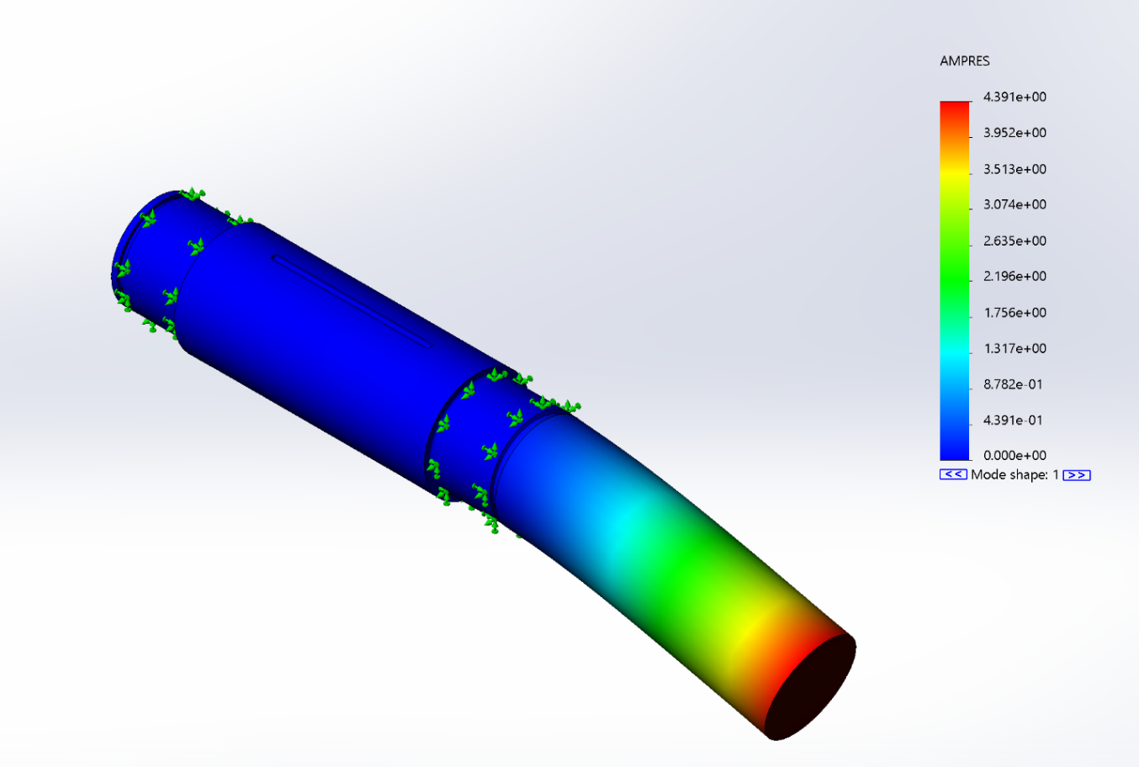
Figure 4.7 – Resonant Frequency Plots (Input and Output Respectively)

The parts easily passed these FEA trials. The von Mesis stresses were never very close to the yield strength of the material and well within the desired factor of safety. The shafts do not deflect more than a small fraction of a thousandth of an inch, so the gears will be able to mesh properly. And finally, the resonant frequencies do not match the operating frequency of either shaft (30 hz).

Bearings

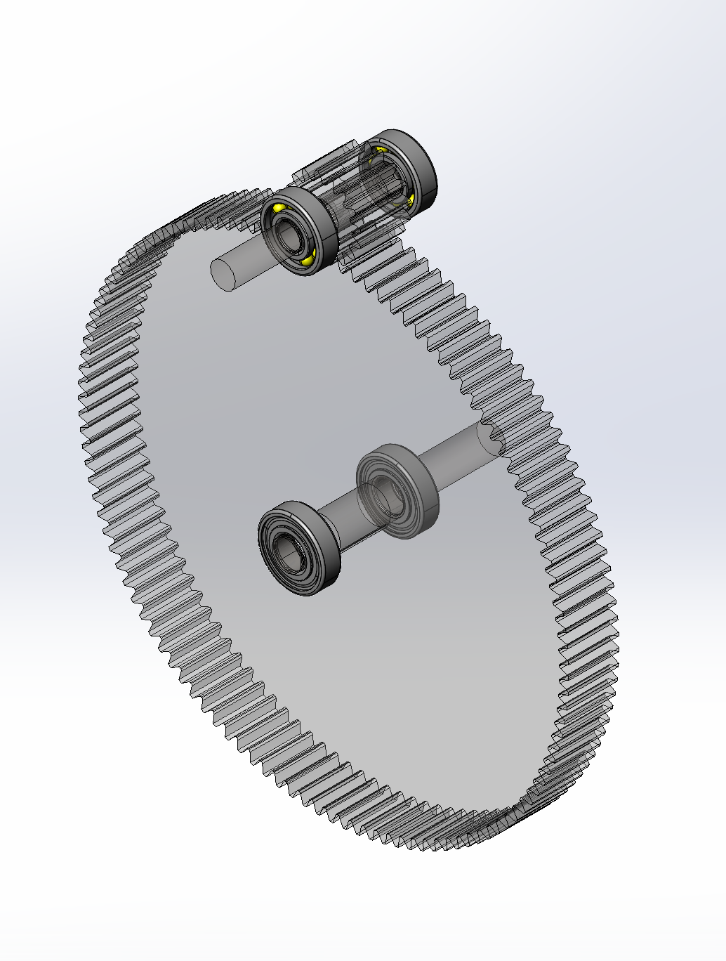
Figure 4.8 – Bearings

Loading and Resultant Force Calculations

The force a bearing in this gear box assembly experiences is half of the force calculated between the gears (as is clear in the FBD from section 4.1.1). The selected bearings had a far higher static rating than the force calculated in the FBD because the minimum fatigue rating had a far higher requirement and bearings that met it could handle high static loads.

C10 Life Calculations

To find bearings which met the lifetime requirement of 4000 hours, an adjusted C10 load had to be calculated. Equation 9 transforms the static load and design life into the minimum fatigue load the bearing is required to handle for one million cycles. With the minimum static and fatigue load requirements and the minimum shaft diameter requirements from section 4.3, a set of roller bearings were selected for each shaft.

Case

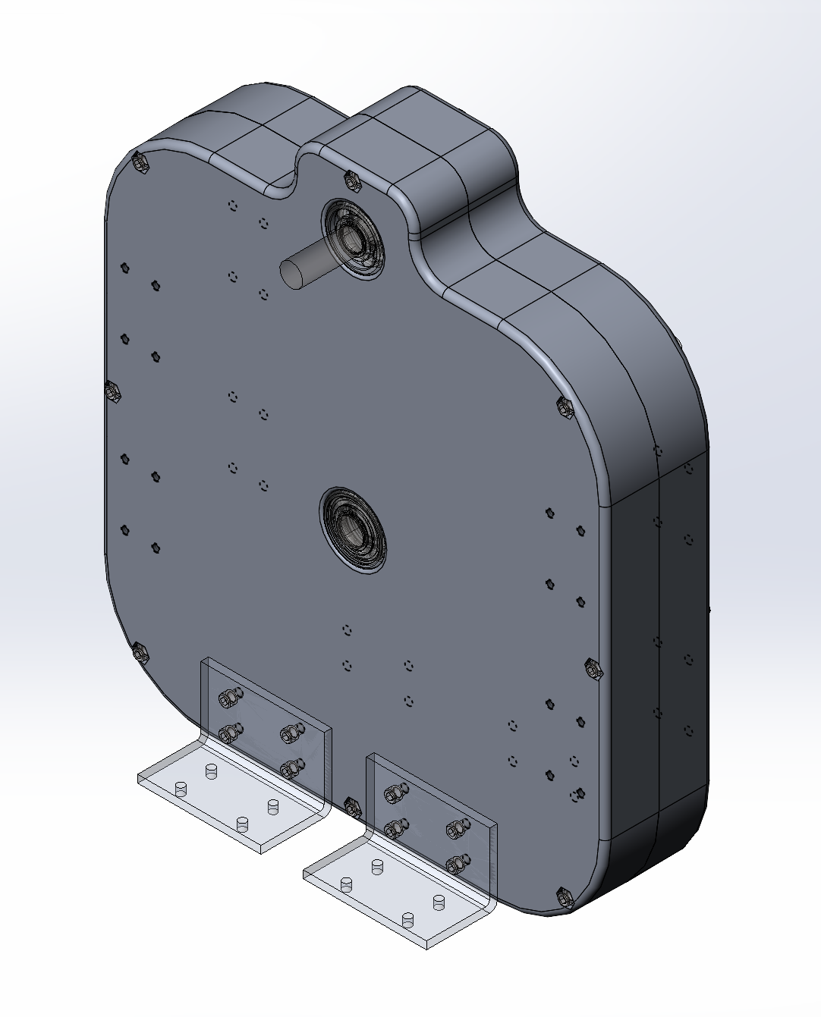
Figure 4.9 – Case

Features

The gearbox case is composed of two of the same aluminum sand-casted part. Certain holes (like where the bearing is pressed in and the bolt holes) are machined after the casting to ensure the fit of crucial parts. The two halves are fastened by eight ¼-20 bolts. There are several ¼-20 threaded holes along the bottom and sides of the case for a variety of mounting options.

Interfaces

Part Outer | Part Inner | Fit
Gear | Gear Shaft | FN3
Pinion | Pinion Shaft | FN2
Gear Bearing | Gear Shaft | LN2
Pinion Bearing | Pinion Shaft | LN2
Gear Shaft | Gear Key | FN2
Pinion Shaft | Pinion Key | FN2
Half Case | Gear Bearing | FN1
Half Case | Pinion Bearing | FN1
Retaining Ring Output | Gear Shaft | Manufacturer Specified
Retaining Ring Input | Pinion Shaft | Manufacturer Specified
Half Case | Mounting Hardware | 1/4 20 Hole and Bolts
Mounting Bracket | Mounting Hardware | 1/4 20 Threads

Drawings
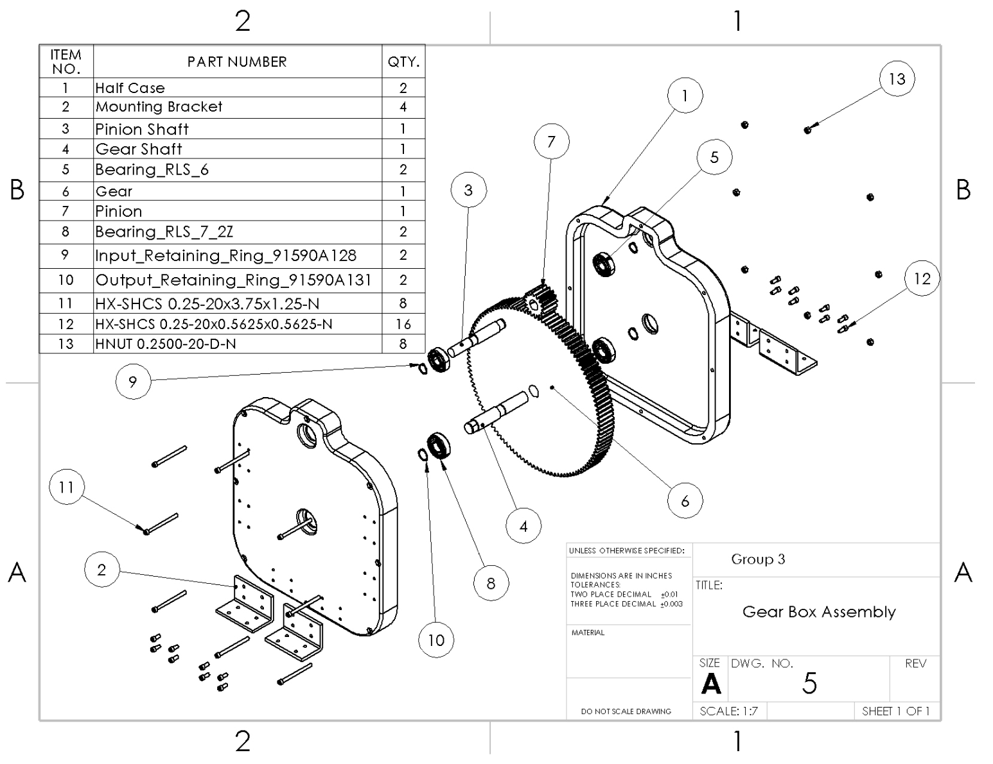
Figure 5.1 – Gear Box Assembly Drawing
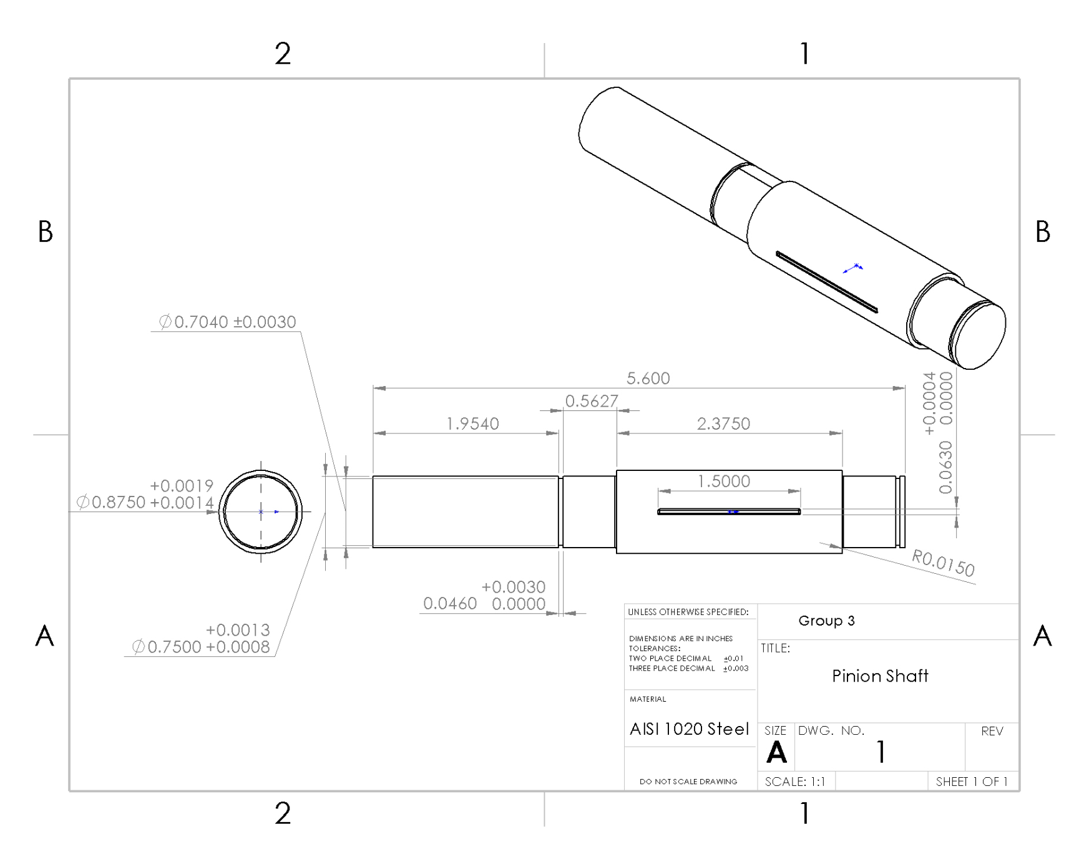
Figure 5.2 – Pinion Shaft Drawing
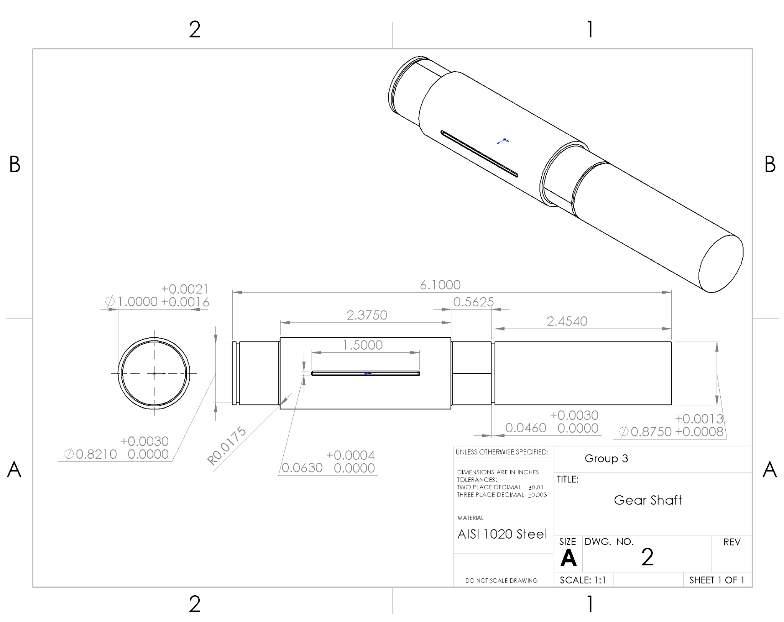
Figure 5.3 – Gear Shaft Drawing
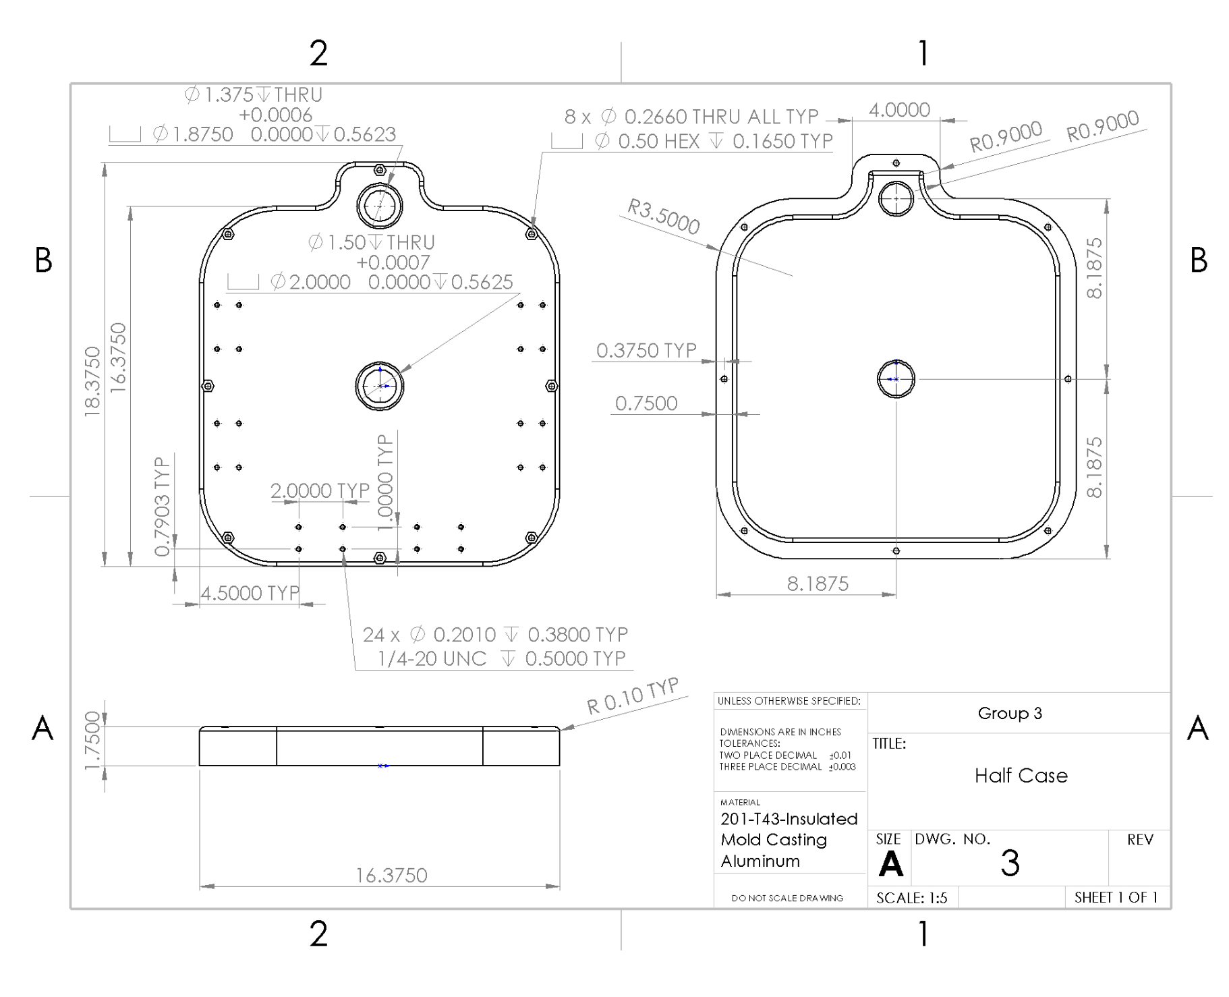
Figure 5.4 – Case Drawing
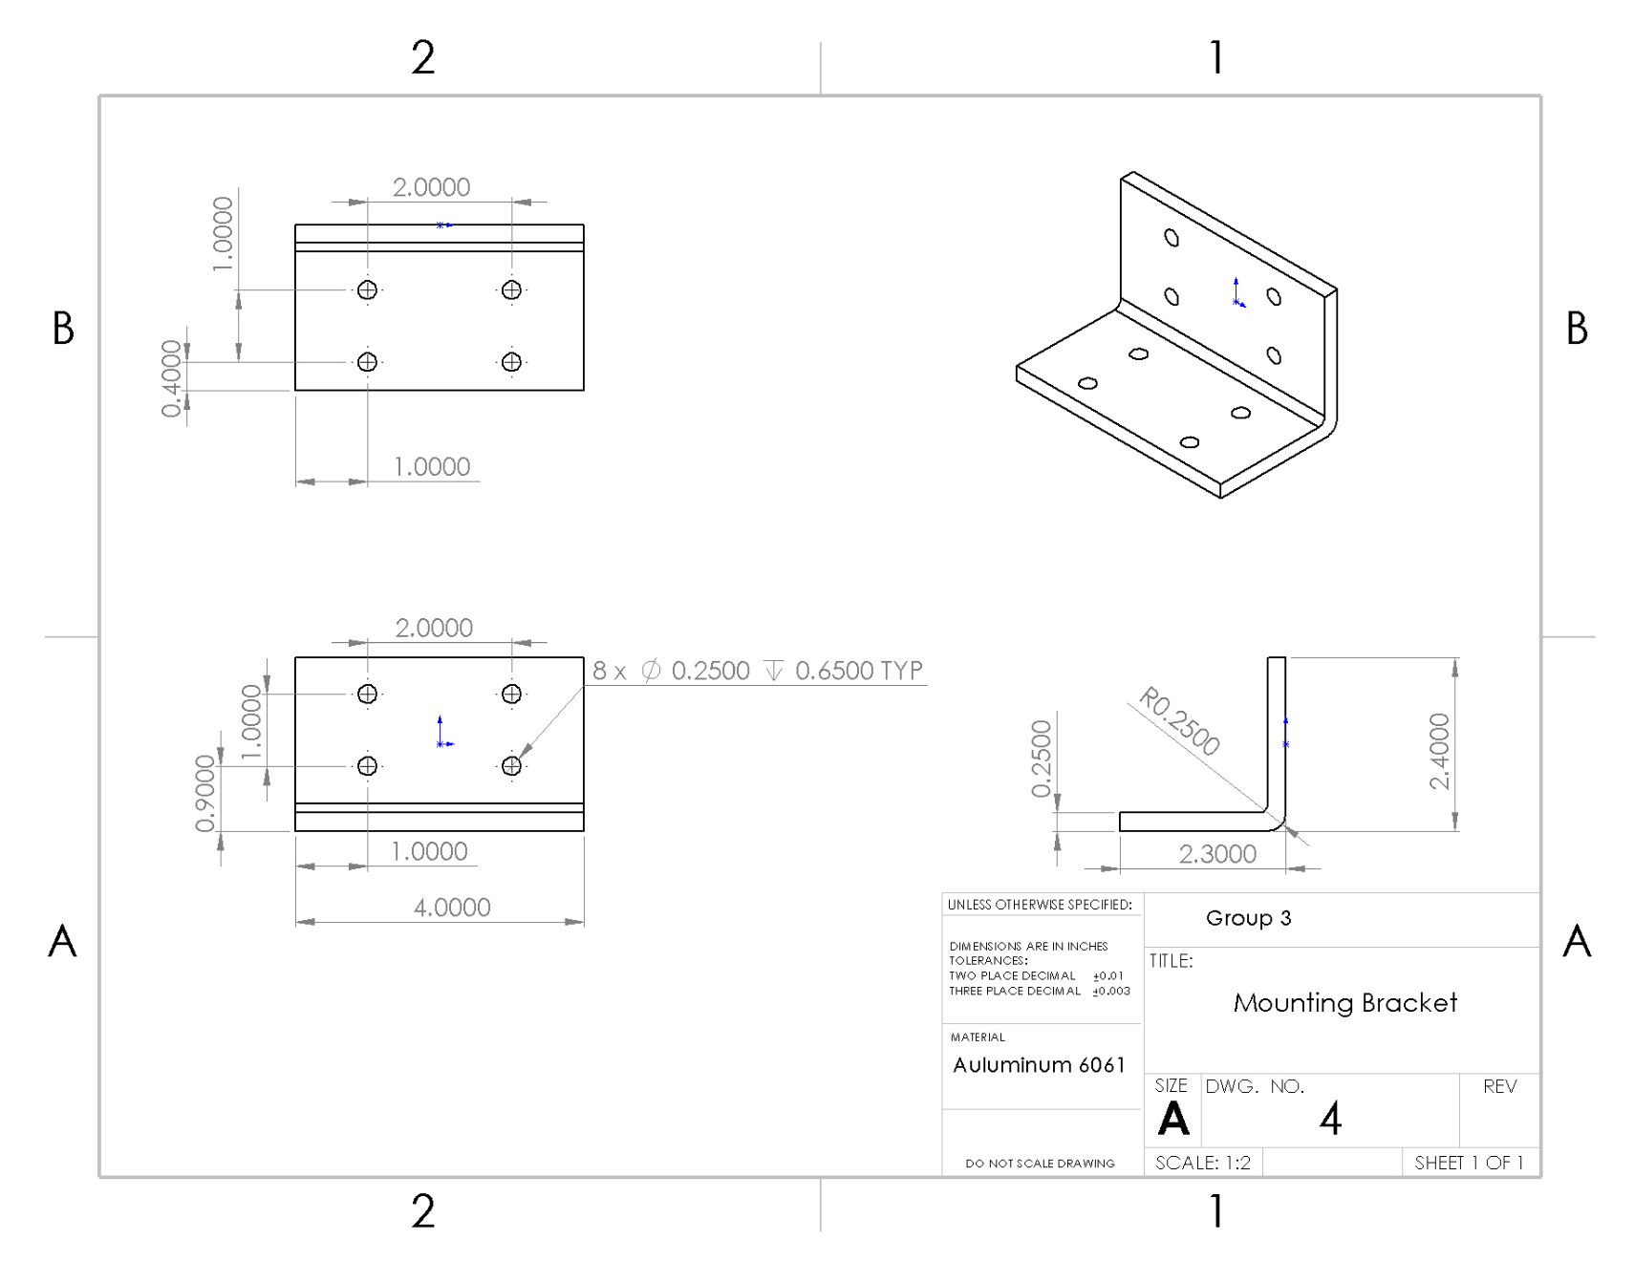
Figure 5.5 – Mounting Bracket Drawing
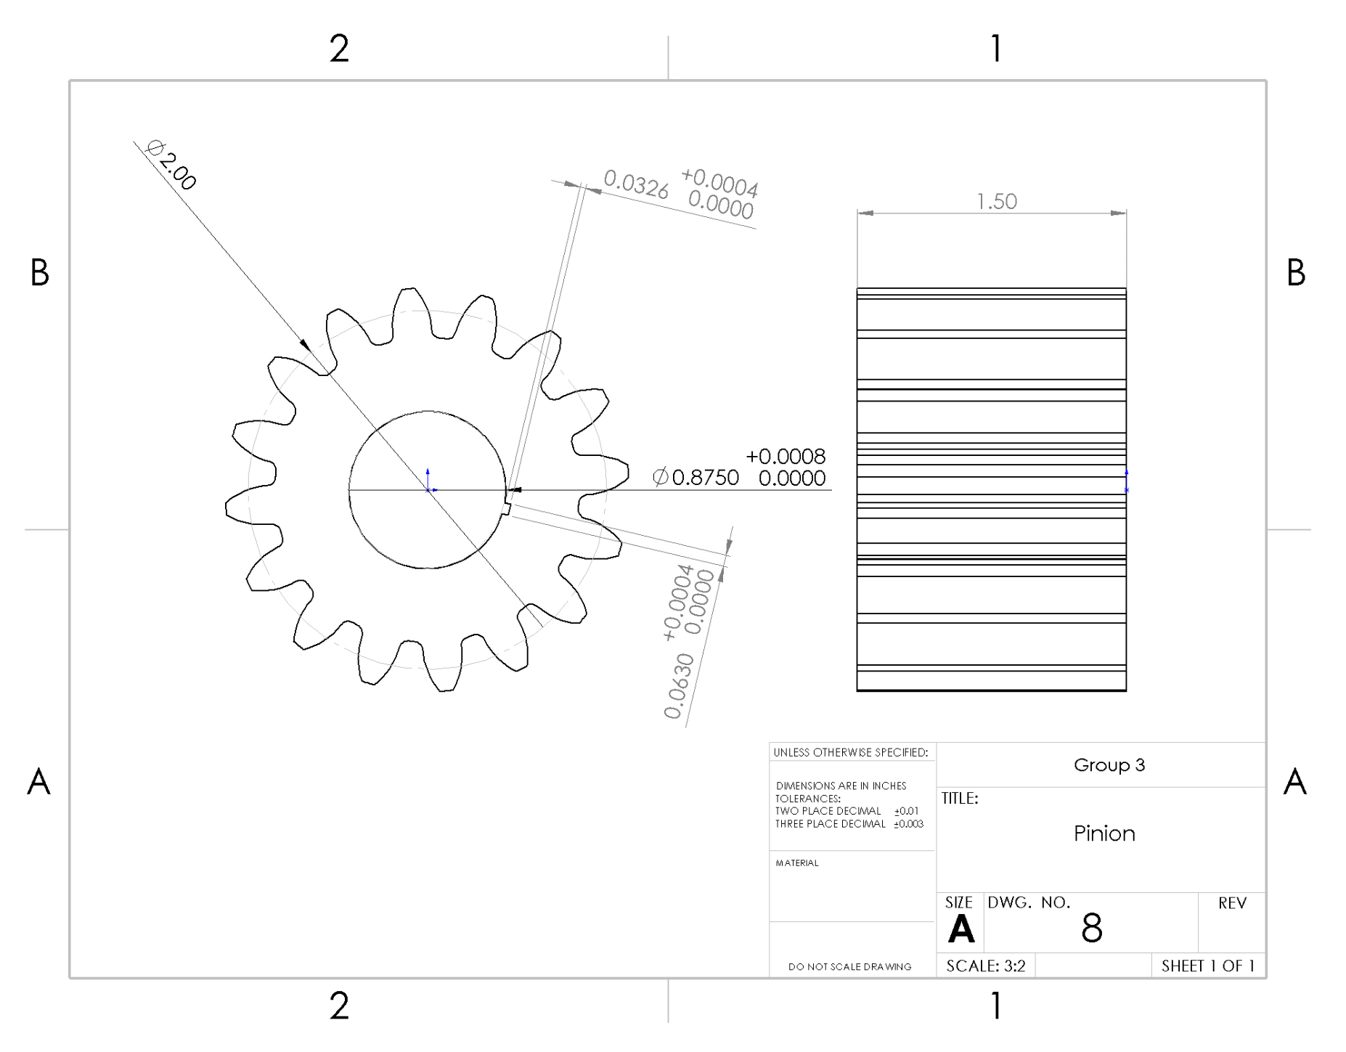
Figure 5.6 – Pinion Drawing
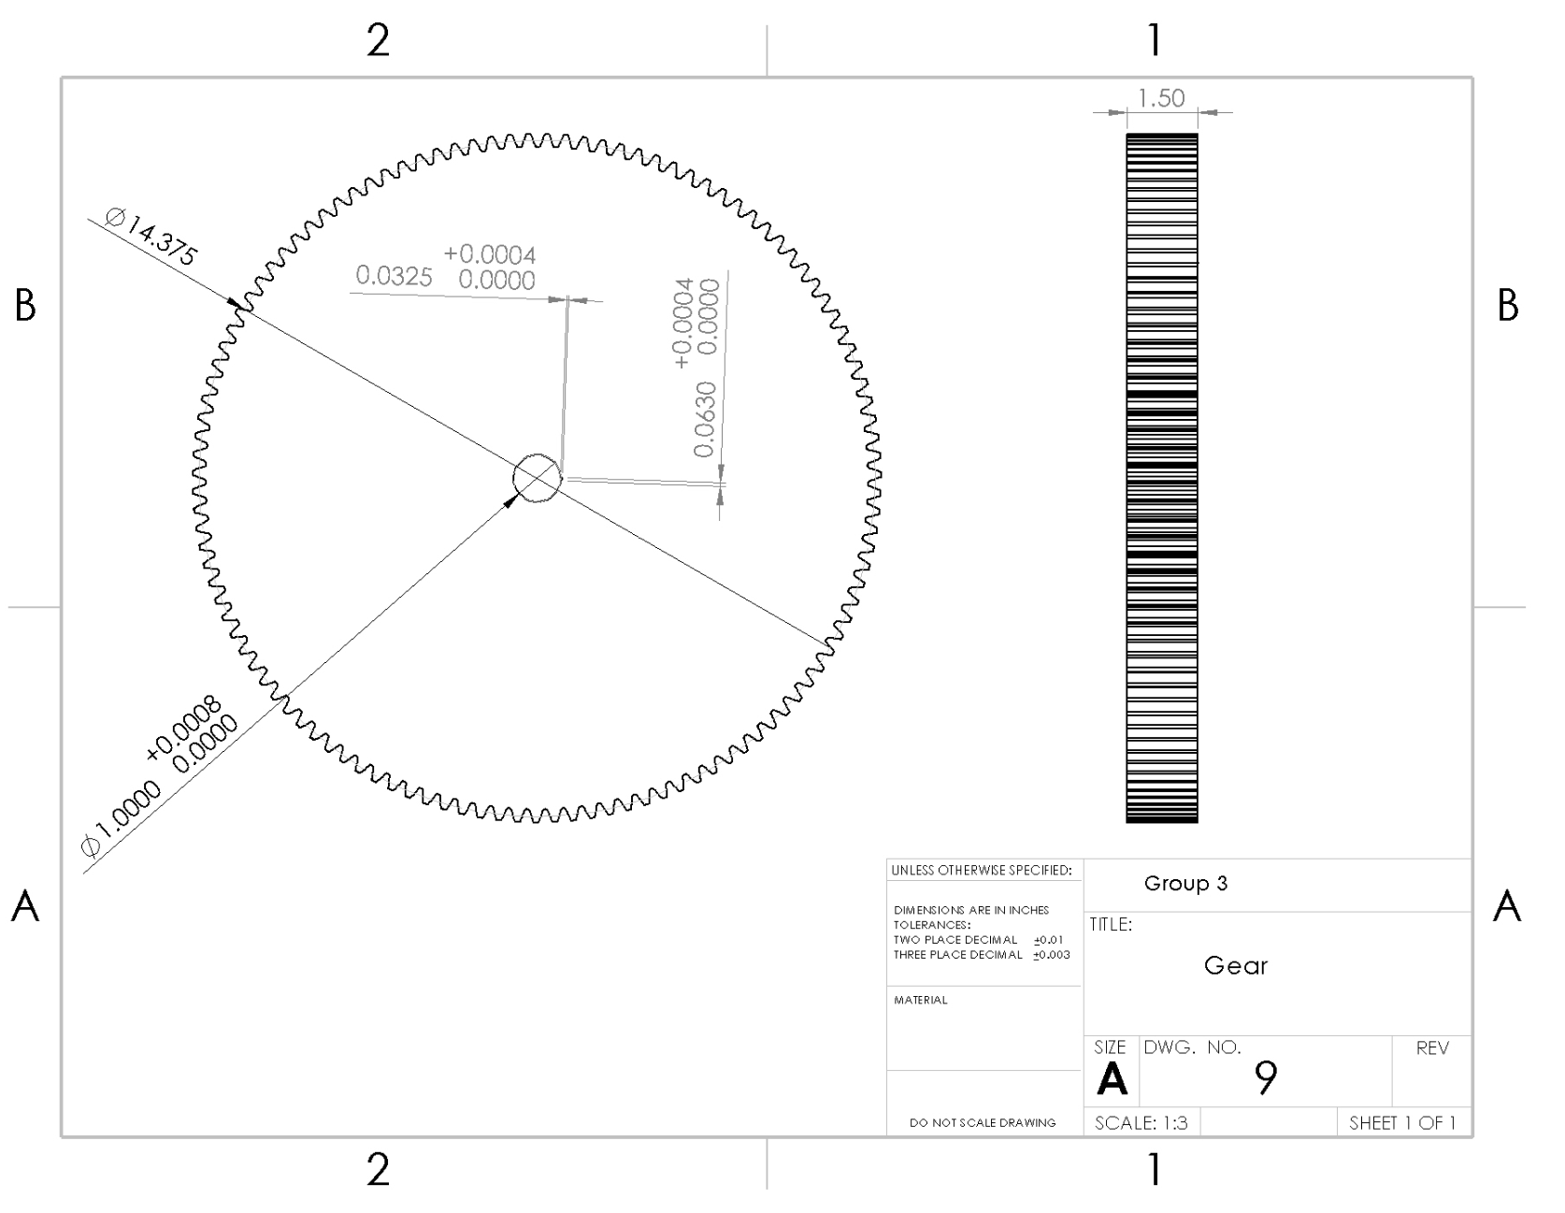
Figure 5.7 – Gear Drawing
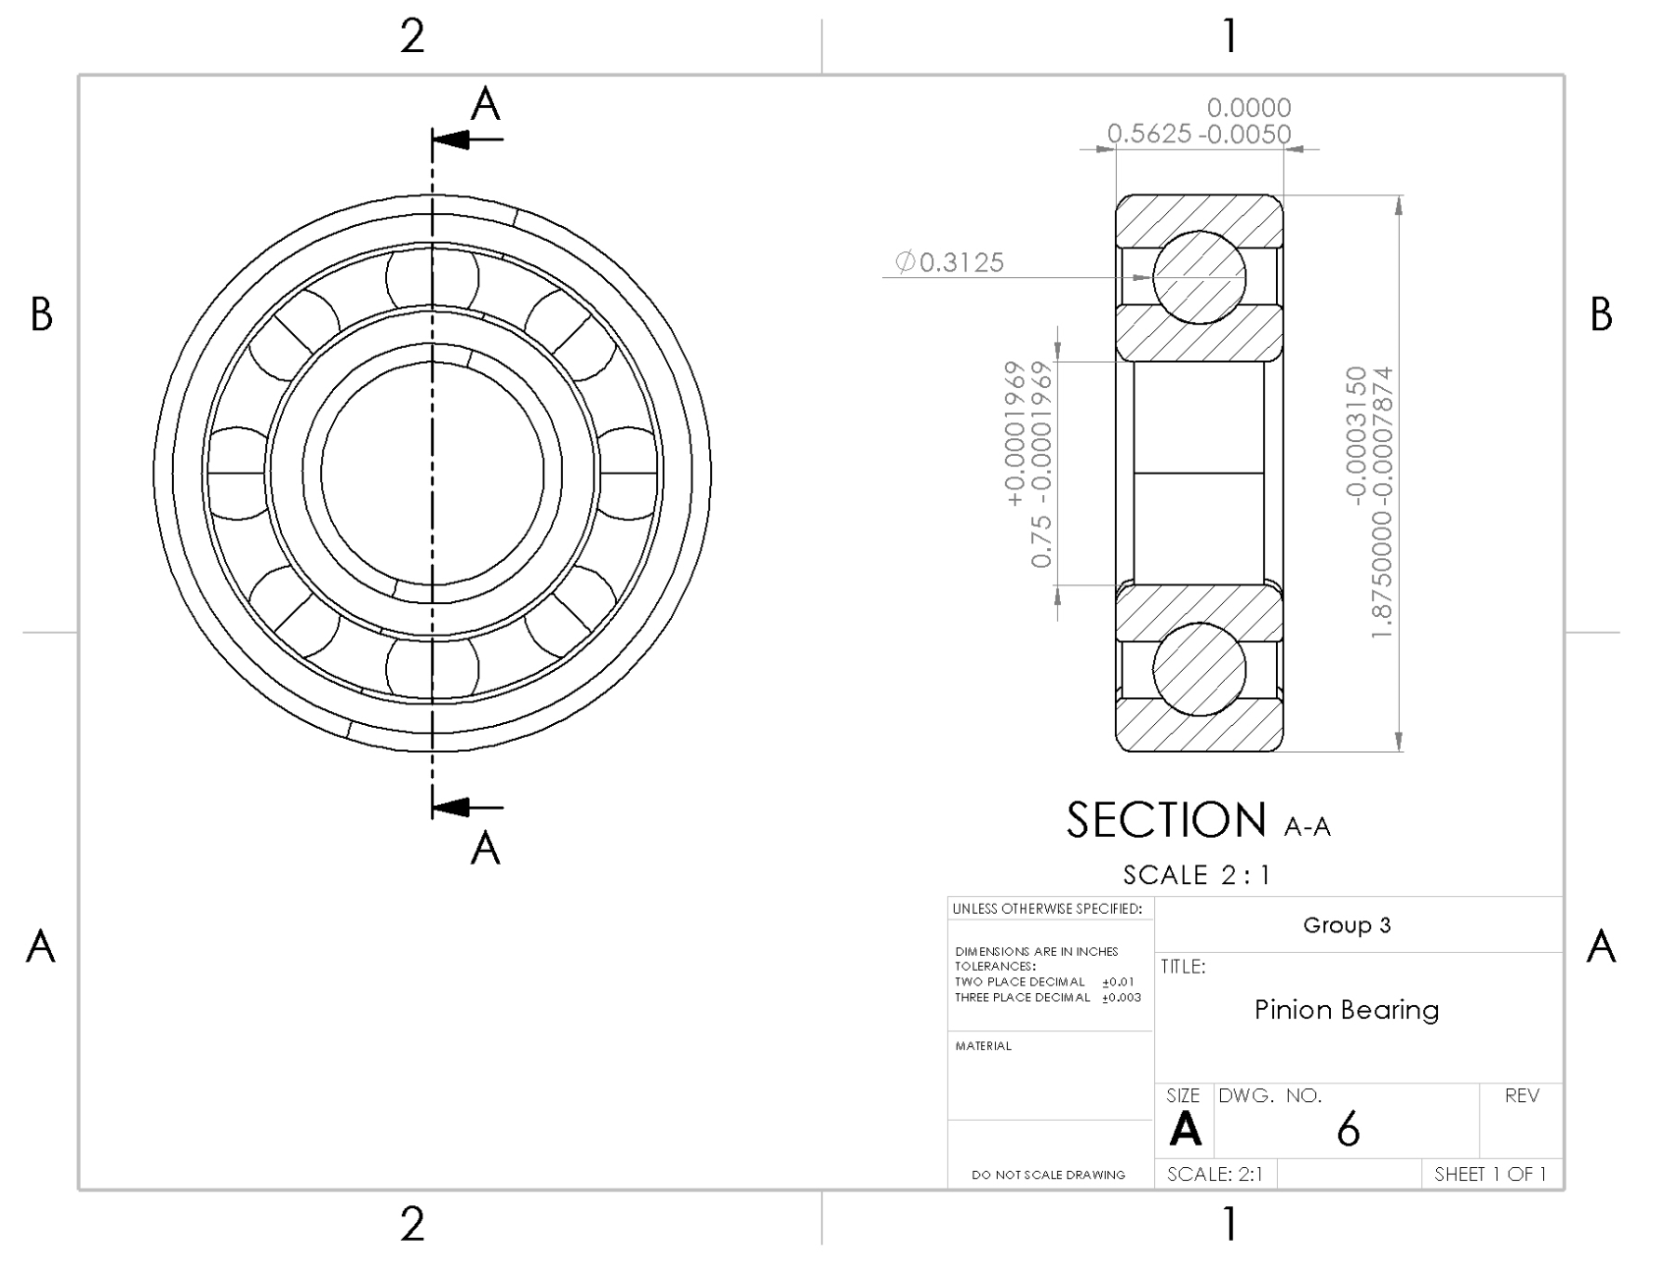
Figure 5.8 – Pinion Bearing Drawing
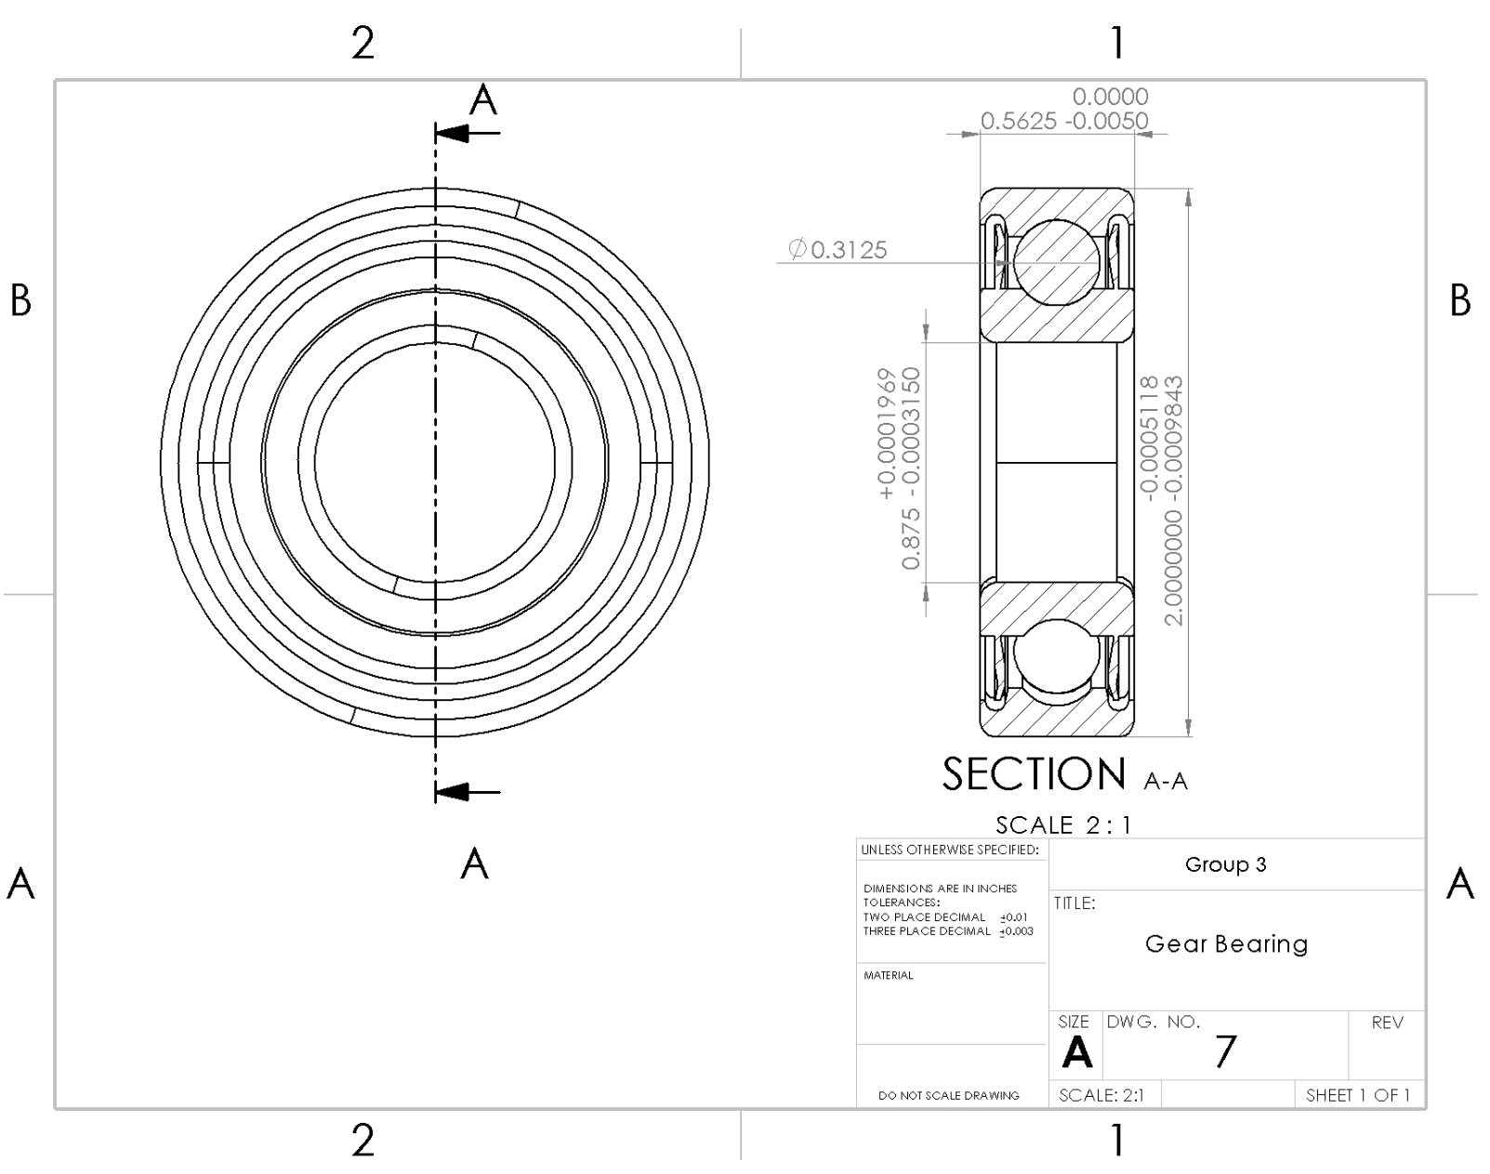
Figure 5.9 – Gear Bearing Drawing

Conclusions

The goal of the project was to design a single-reduction spur gear box reducer that can receive an input power of three horsepower at an input speed of 1800 revolutions per minute. The required gear ratio was 7.2 with a one percent acceptable variation. The true gear ratio of the selected gears was 7.1875 which was in the acceptable margin. The pressure angle for the spur gears was twenty degrees. The shaft’s static factor of safety is well within the minimum of 2.25, and the same is true for the fatigue minimum factor of safety of 1.25. FEA shows minimum static factors of safety close to 8 because the shaft diameter was rounded up to meet the bore of the gears and bearings chosen to handle the gearbox loads. The fit between the shaft and bearings are designed for an LN-2 fit, and the bearings chosen have a design life of 4,000 hours at their respective RPM. The gears were sourced from Rush Gears, the bearings from SKF, and the retaining rings and hardware from McMaster-Carr.
Should future iterations or modifications of the gear box be required, these changes will require much less work because the analysis that guides part selection for the assembly has been codified in a spreadsheet calculator in which design requirement inputs can be modified and the changes reflected for the whole analysis.

References

[1] "Main Types of Industrial Gearboxes." Bronte. Accessed December 8, 2020. https://www.bpel.co.uk/post/4-main-types-of-industrial-gearbox.
[2] "Gearbox Applications." SAMP. Accessed December 10, 2020. https://www.sampingranaggi.com/applications/gearboxes/.
[3] Budynas, Richard G., and J. Keith Nisbett. Shigley's Mechanical Engineering Design. New York: McGraw Hill Education, 2020. https://player-ui.mheducation.com/#/epub/sn_7dfa#epubcfi(%2F6%2F6%5Bdata-uuid-c5071462f4ee4aa1bee5670c6ffa357a%5D!%2F4%2F1:0).
[4] "The Importance of Material Selection During the Engineering Design Process." Engineering Science Analysis, Manufacturing, & Design. Last modified September 29, 2017. Accessed December 11, 2020. https://www.esacorp.com/the-importance-of-material-selection-during-the-engineering-design-process/.
[5] "Deep groove ball bearings." SKF. https://www.skf.com/us/products/rolling-bearings/ball-bearings/deep-groove-ball-bearings.
[6] "Spur Gears." Rush Gears. https://www.rushgears.com/tech-tools/part-search/gears/type/spur.
[7] "Force and Shrink Limits and Fits For Cylindirical Parts." Coban Engineering. https://www.cobanengineering.com/Tolerances/ANSIForceShrinkFits.asp.

